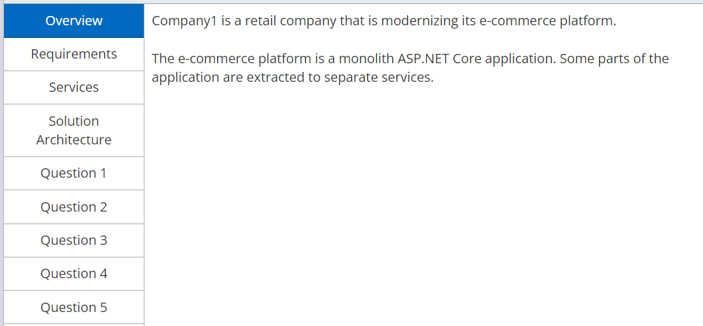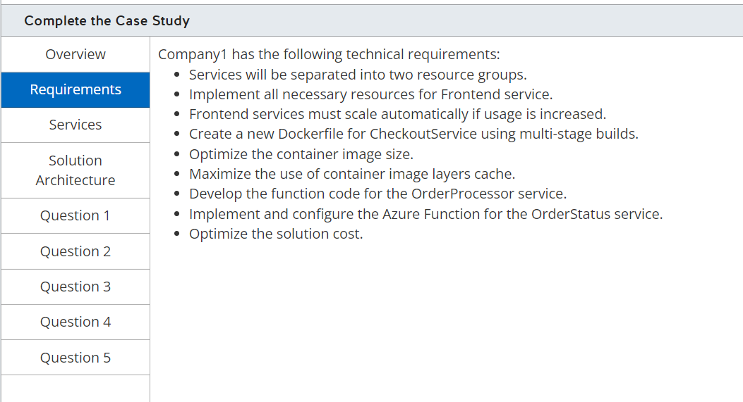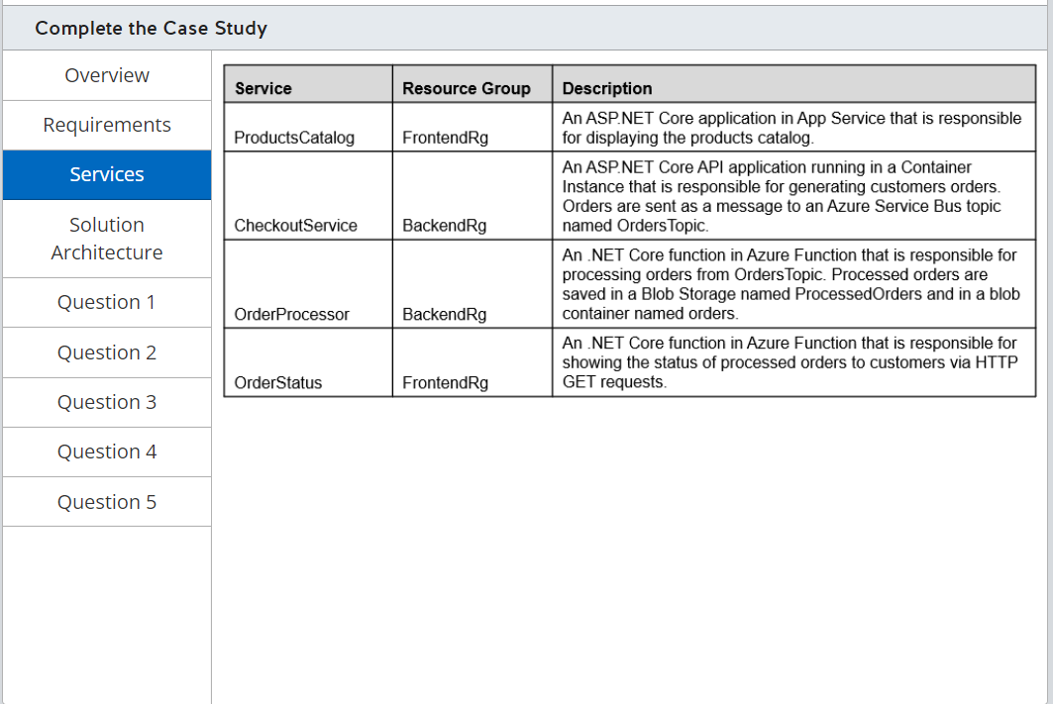

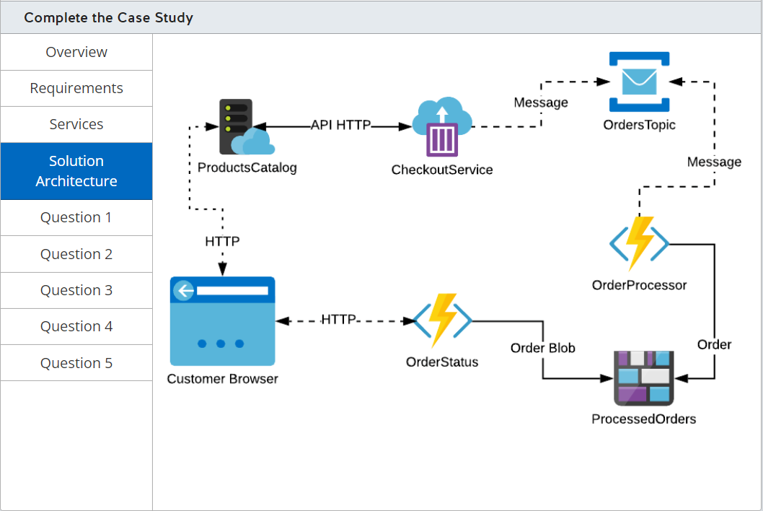

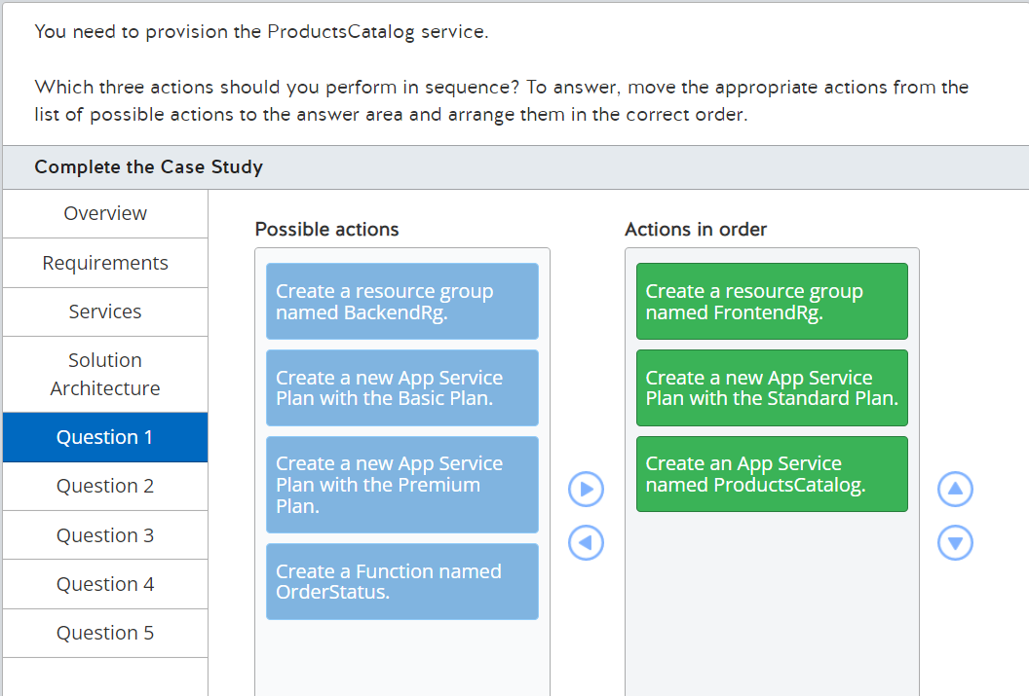

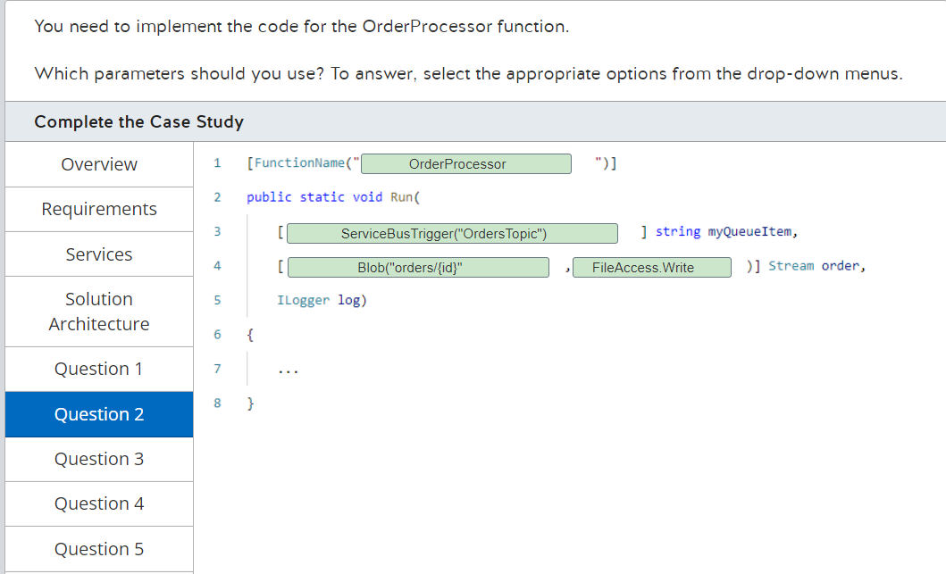

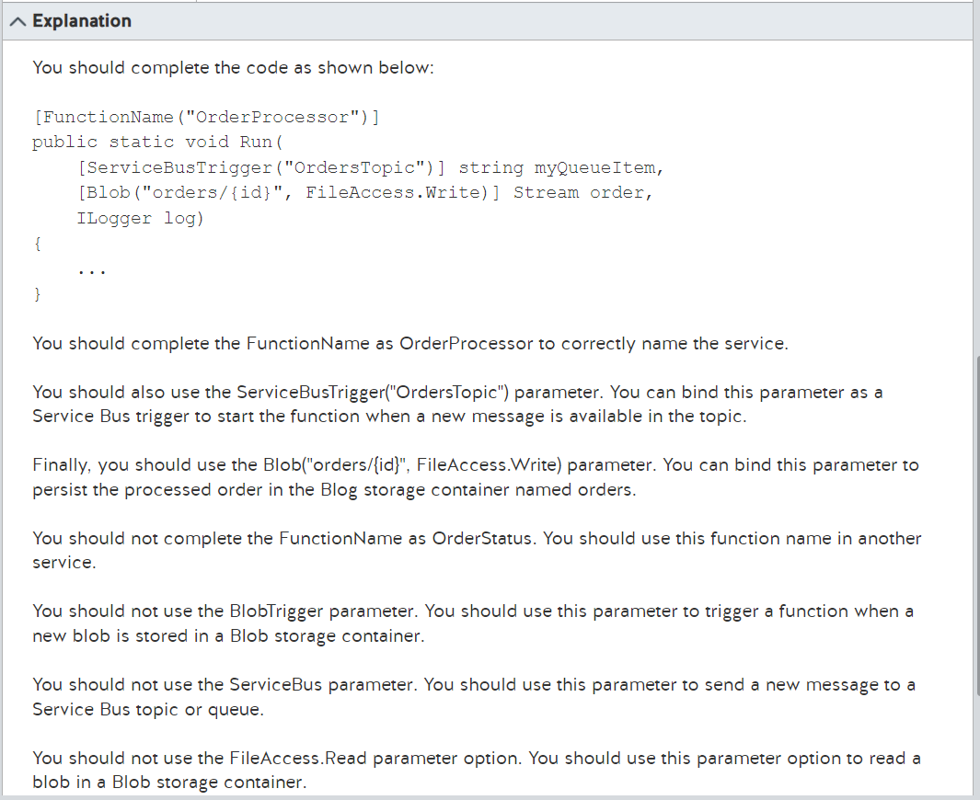

<https://docs.microsoft.com/en-us/azure/azure-functions/functions-triggers-bindings?tabs=csharp>

<https://docs.microsoft.com/en-us/azure/azure-functions/functions-bindings-storage-blob-output?tabs=in-process%2Cextensionv5&pivots=programming-language-csharp>

<https://docs.microsoft.com/en-us/azure/azure-functions/functions-bindings-service-bus-trigger?tabs=in-process%2Cextensionv5&pivots=programming-language-csharp>

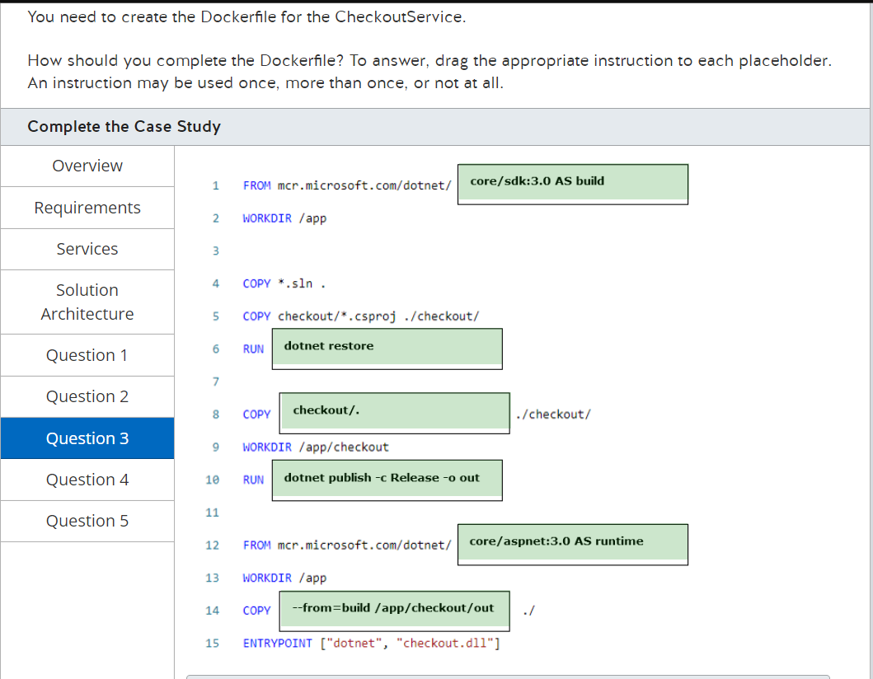

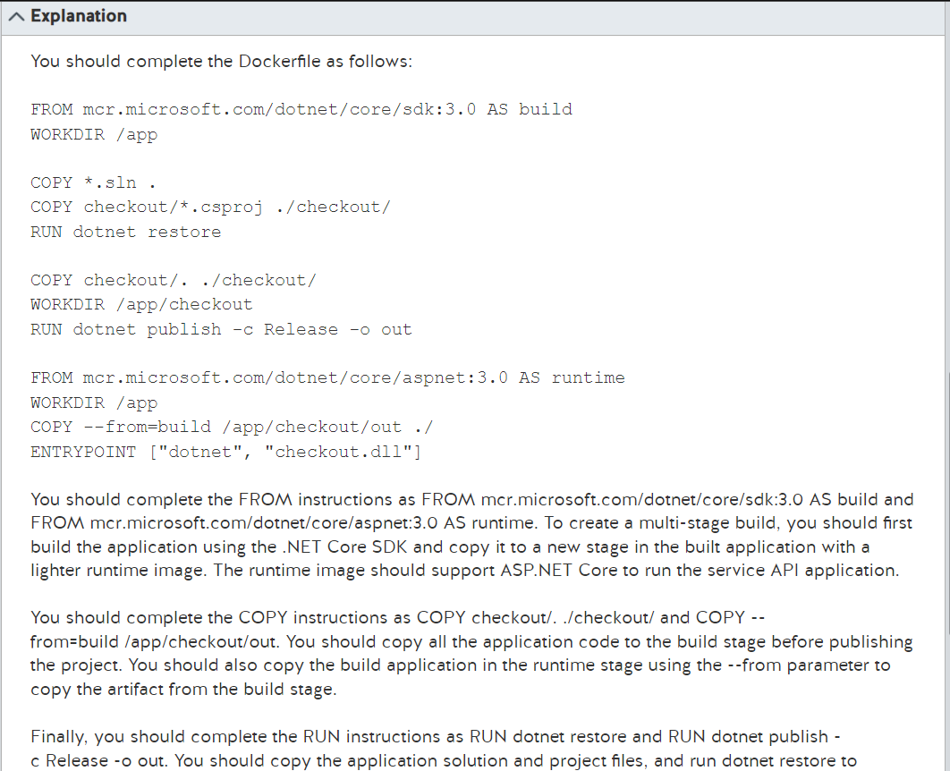

<https://docs.microsoft.com/en-us/aspnet/core/host-and-deploy/docker/building-net-docker-images?view=aspnetcore-3.0>

<https://docs.docker.com/engine/reference/builder/>

<https://docs.docker.com/develop/develop-images/multistage-build/>

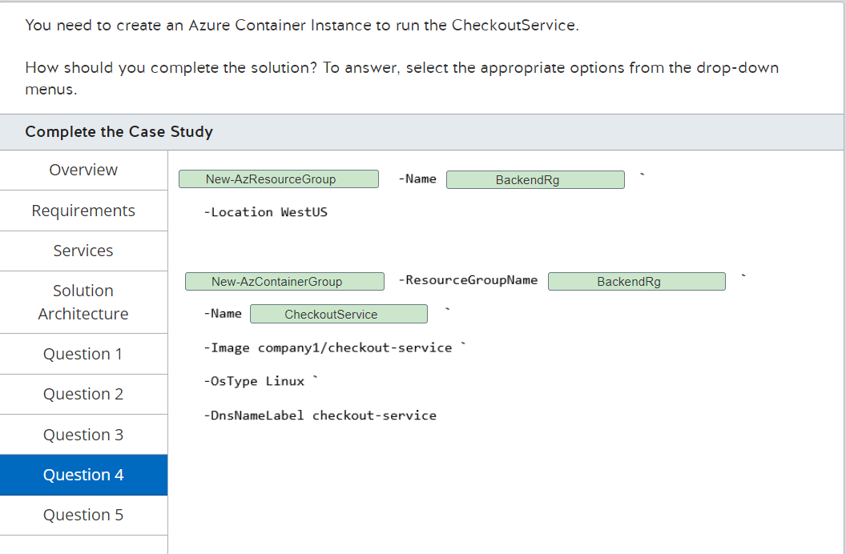

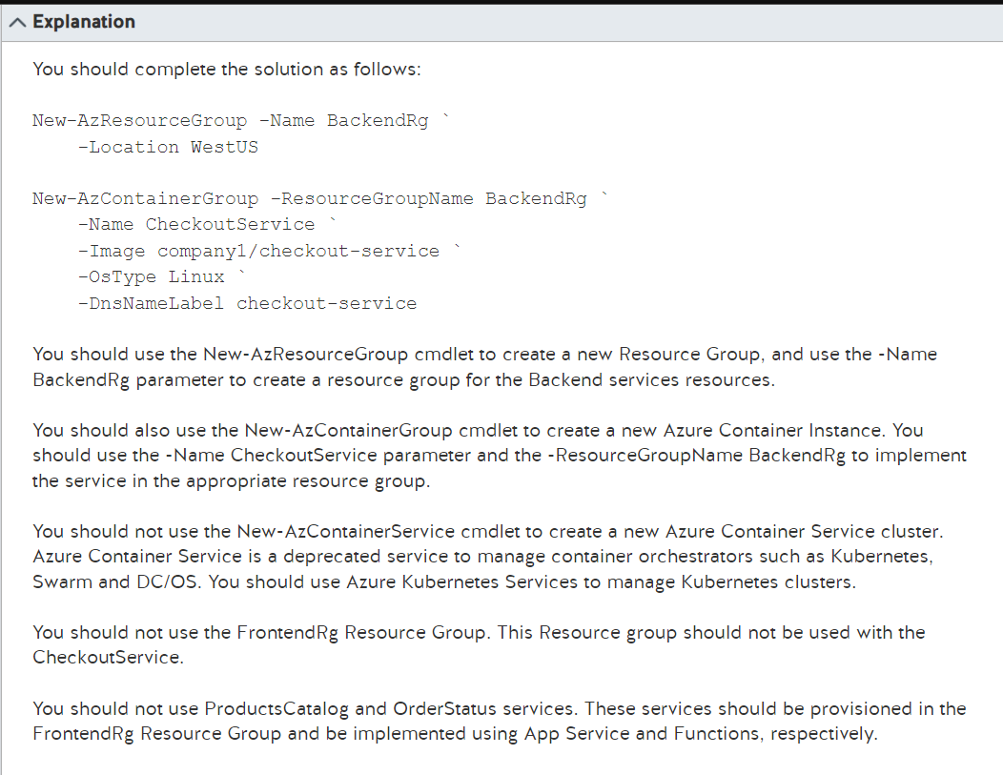

<https://docs.microsoft.com/en-us/azure/container-instances/container-instances-quickstart-powershell>

<https://docs.microsoft.com/en-us/powershell/module/az.compute/new-azcontainerservice?view=azps-0.10.0&viewFallbackFrom=azps-3.8.0>

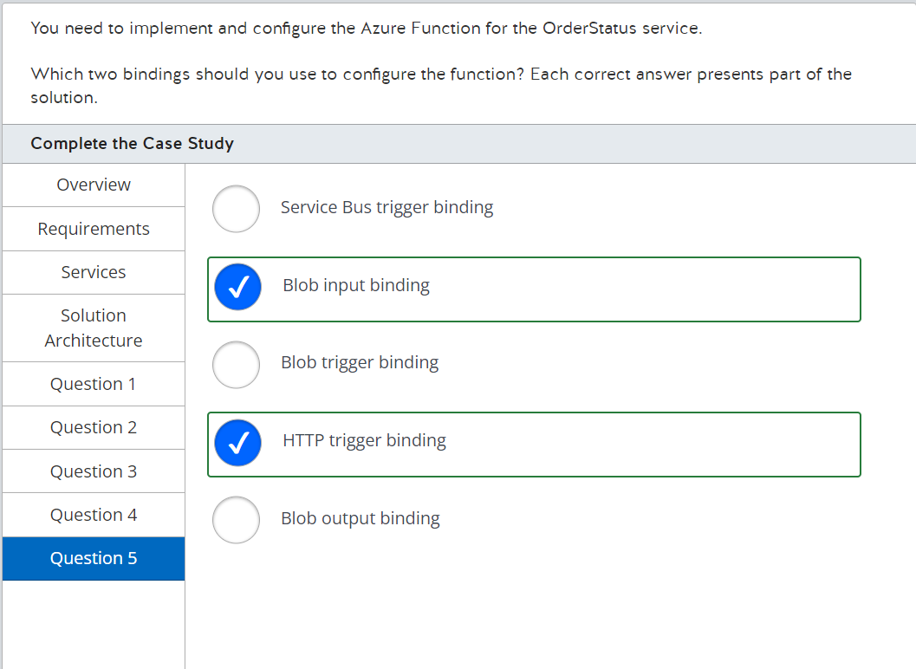

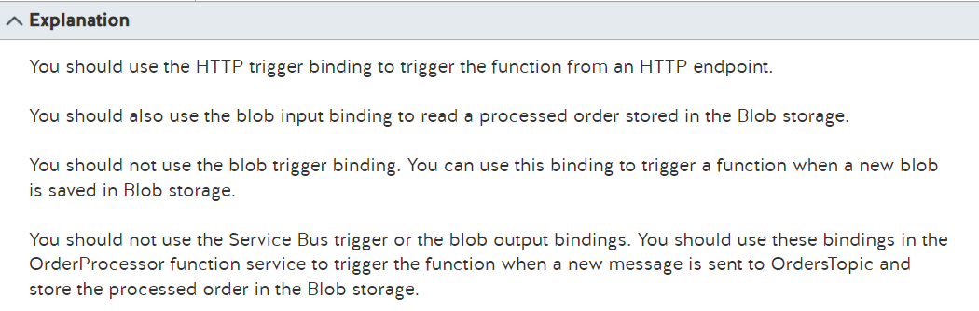

<https://docs.microsoft.com/en-us/azure/azure-functions/functions-triggers-bindings?tabs=csharp>

<https://docs.microsoft.com/en-us/azure/azure-functions/functions-bindings-http-webhook-trigger?tabs=in-process%2Cfunctionsv2&pivots=programming-language-csharp>

<https://docs.microsoft.com/en-us/azure/azure-functions/functions-bindings-storage-blob?tabs=in-process%2Cextensionv5%2Cextensionv3&pivots=programming-language-csharp>

<https://docs.microsoft.com/en-us/azure/azure-functions/functions-bindings-service-bus-trigger?tabs=in-process%2Cextensionv5&pivots=programming-language-csharp>

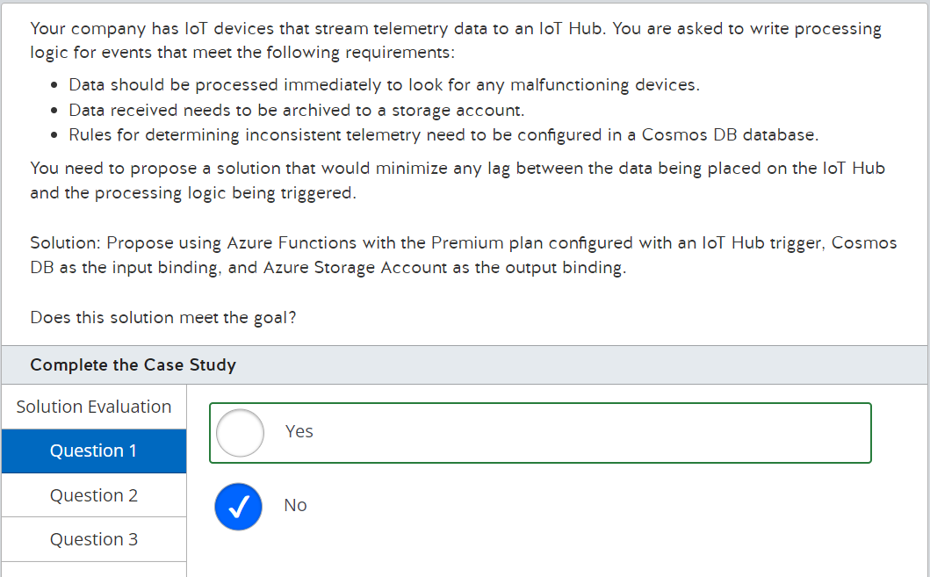

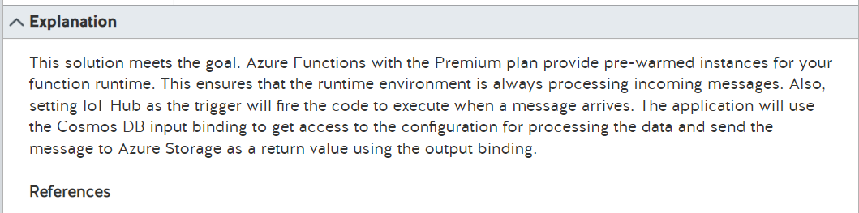

<https://docs.microsoft.com/en-us/azure/azure-functions/functions-triggers-bindings?tabs=csharp>

<https://docs.microsoft.com/en-us/azure/azure-functions/functions-premium-plan?tabs=portal>

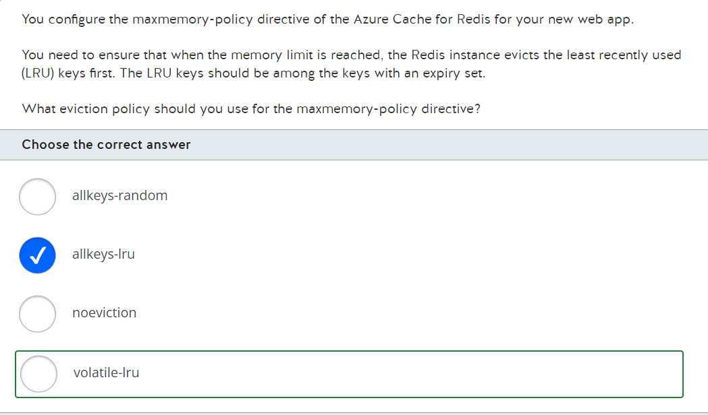

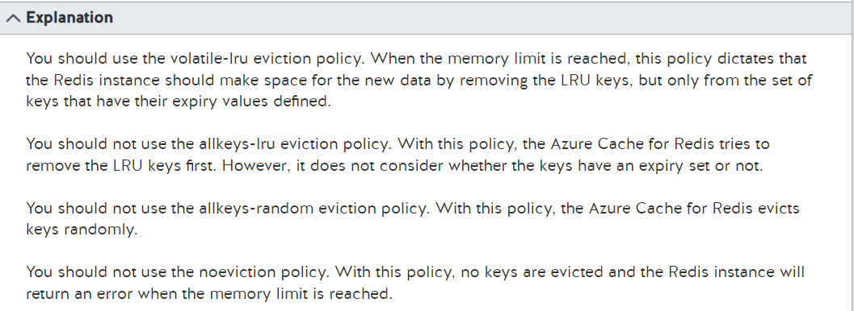

<https://docs.microsoft.com/en-us/azure/azure-cache-for-redis/cache-configure#access-keys>

<https://redis.io/docs/manual/eviction/>

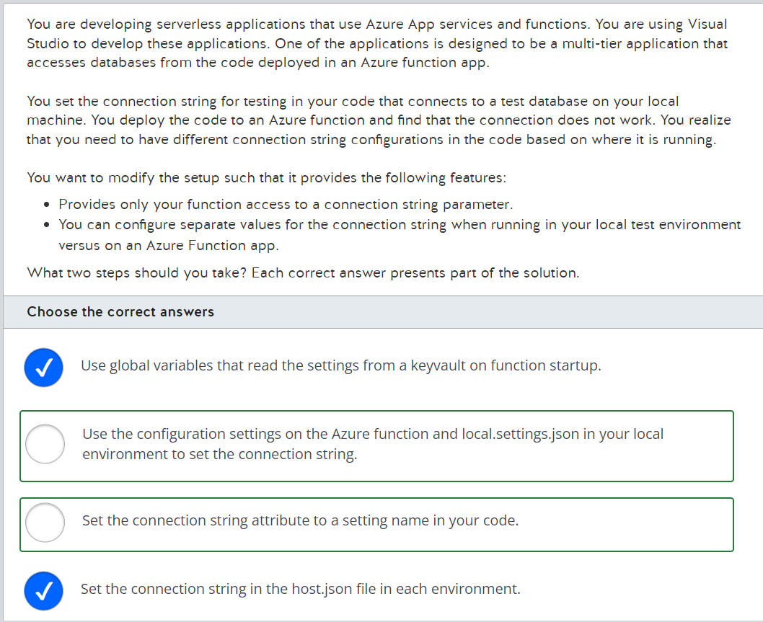

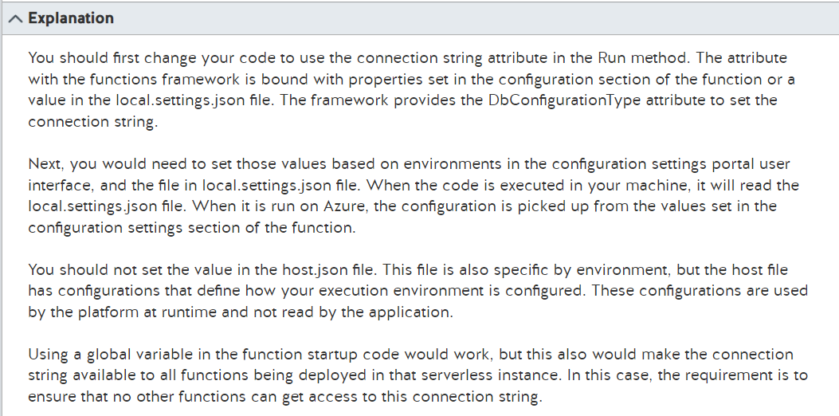

<https://docs.microsoft.com/en-us/dotnet/api/system.data.entity.dbconfigurationtypeattribute?view=entity-framework-6.2.0>

<https://stackoverflow.com/questions/39916981/how-to-specify-entityframework-providername-in-an-azure-function>

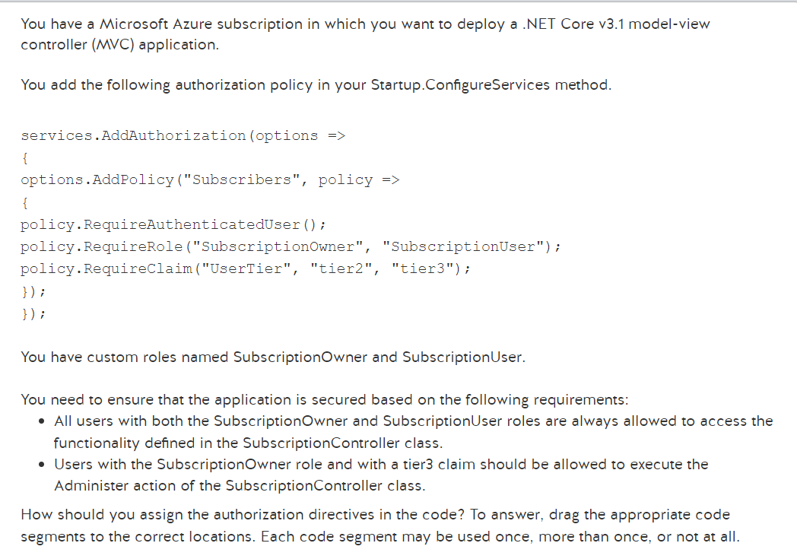

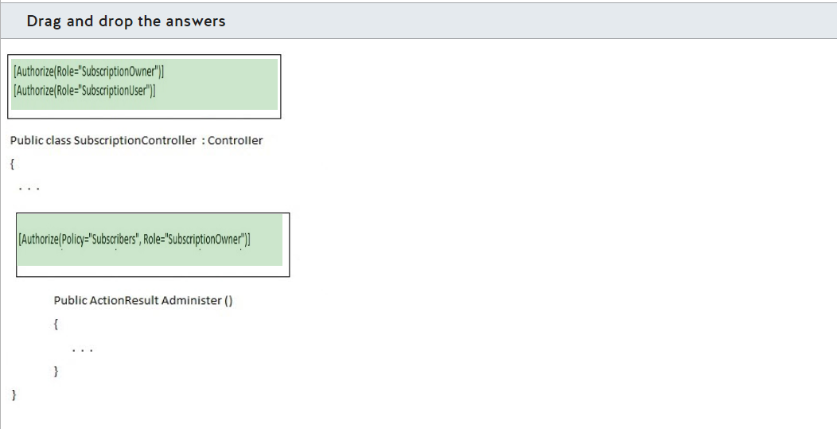

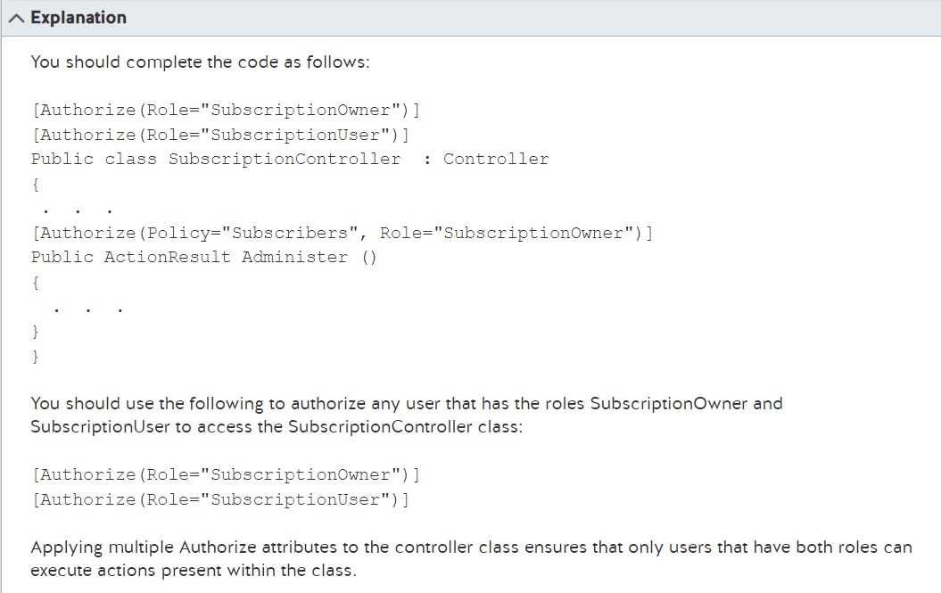

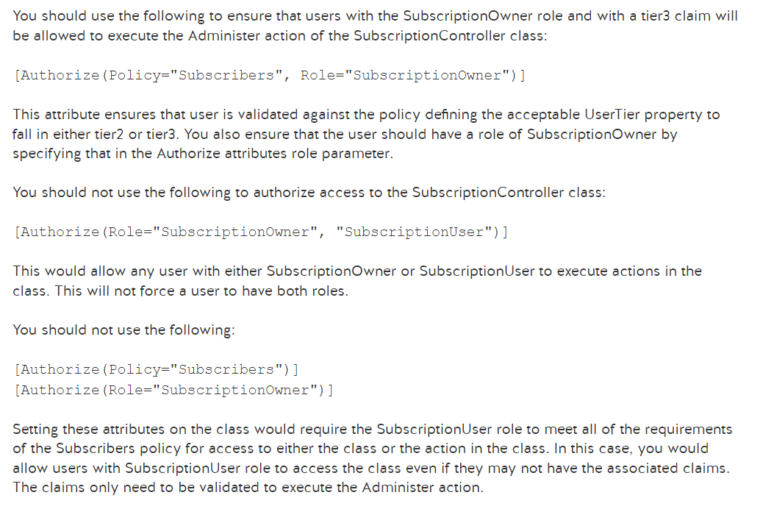

<https://docs.microsoft.com/en-us/aspnet/core/security/authorization/policies?view=aspnetcore-3.1>

<https://docs.microsoft.com/en-us/aspnet/core/security/authorization/roles?view=aspnetcore-3.1>

<https://docs.microsoft.com/en-us/aspnet/core/security/authorization/claims?view=aspnetcore-3.1>

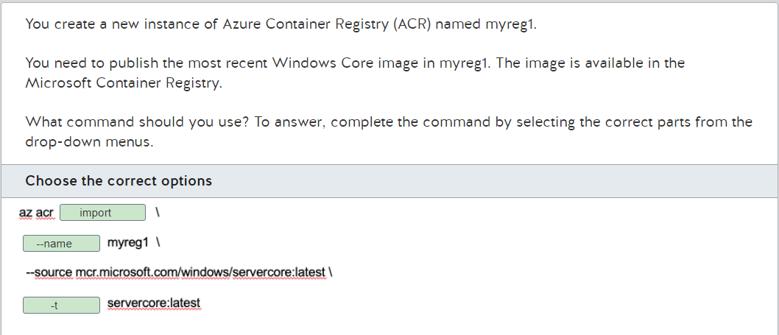

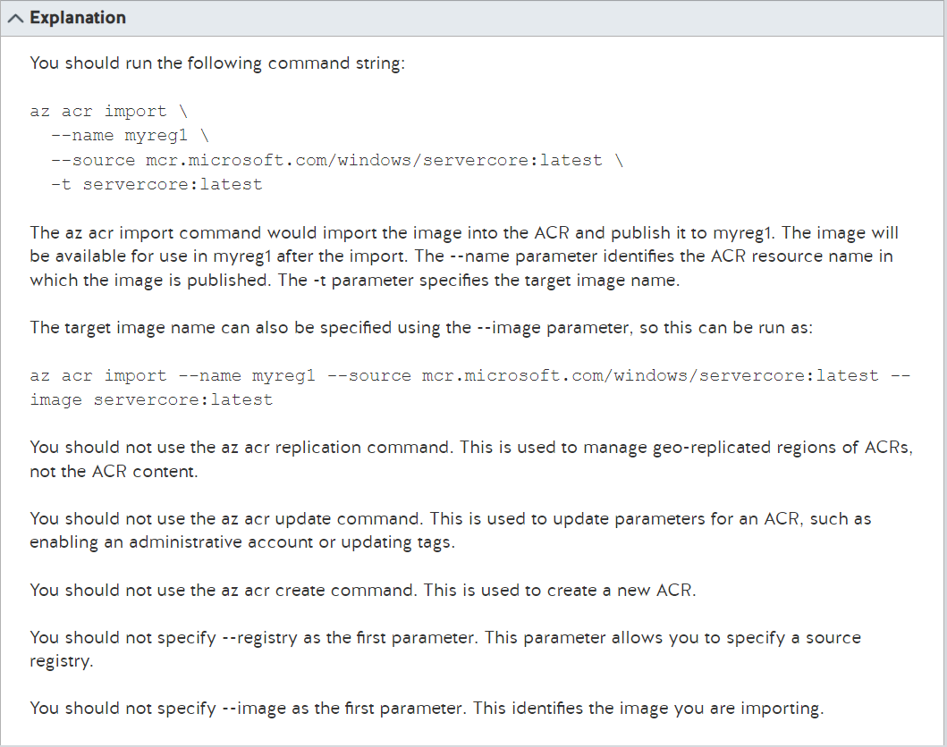

<https://docs.microsoft.com/en-us/azure/container-registry/container-registry-import-images?tabs=azure-cli>

<https://docs.microsoft.com/en-us/cli/azure/acr?view=azure-cli-latest>

<https://docs.microsoft.com/en-us/azure/container-registry/container-registry-tutorial-quick-task>

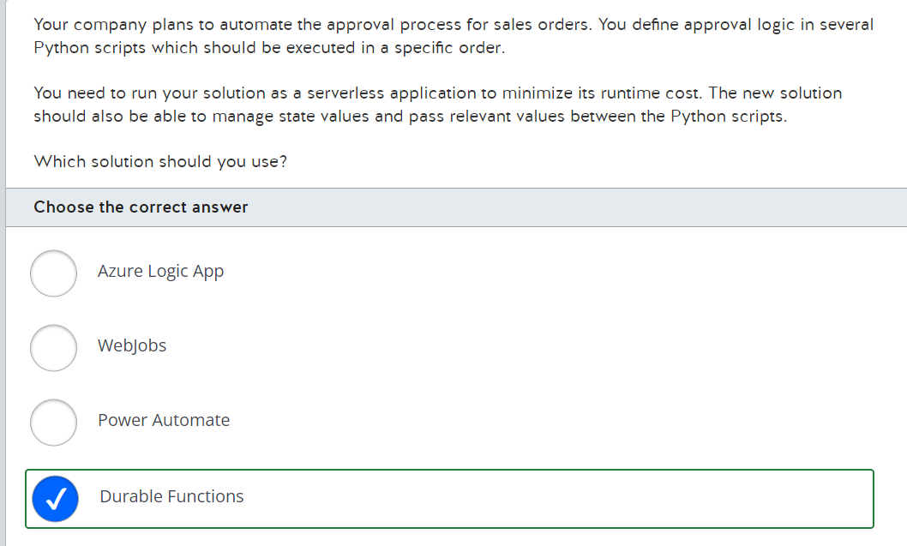

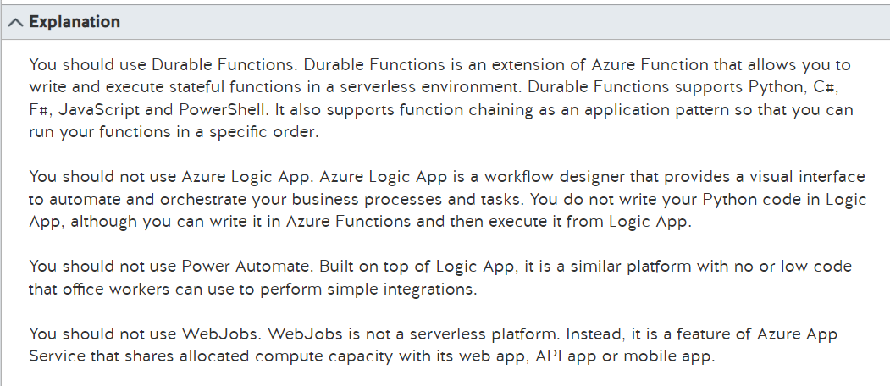

<https://docs.microsoft.com/en-us/azure/azure-functions/durable/durable-functions-overview?tabs=csharp>

<https://docs.microsoft.com/en-us/azure/azure-functions/functions-compare-logic-apps-ms-flow-webjobs?toc=/azure/azure-functions/durable/toc.json>

<https://docs.microsoft.com/en-gb/azure/logic-apps/logic-apps-overview>

<https://docs.microsoft.com/en-us/power-automate/getting-started>

<https://docs.microsoft.com/en-us/azure/app-service/webjobs-create>

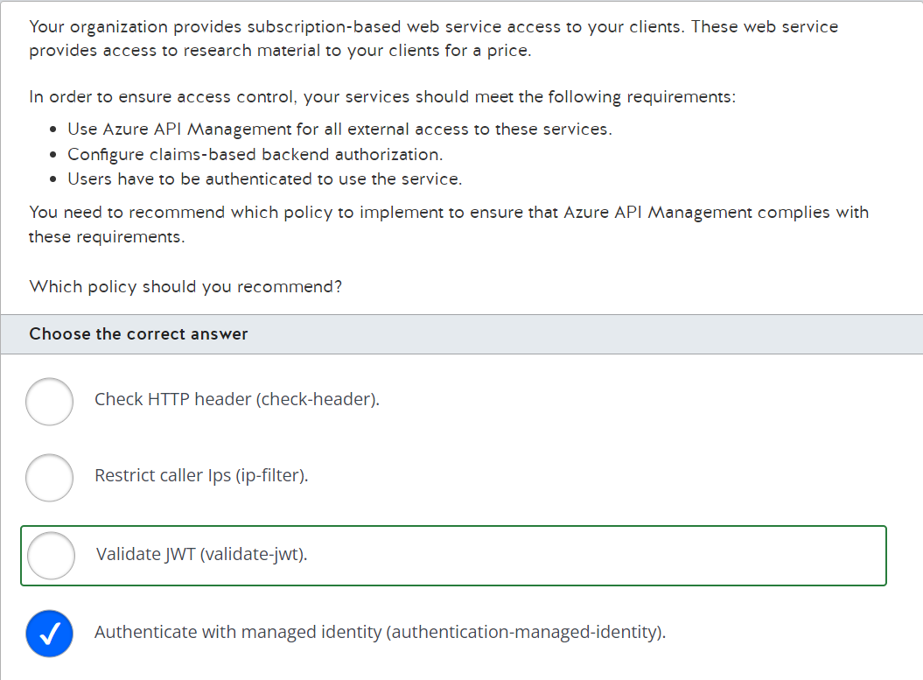

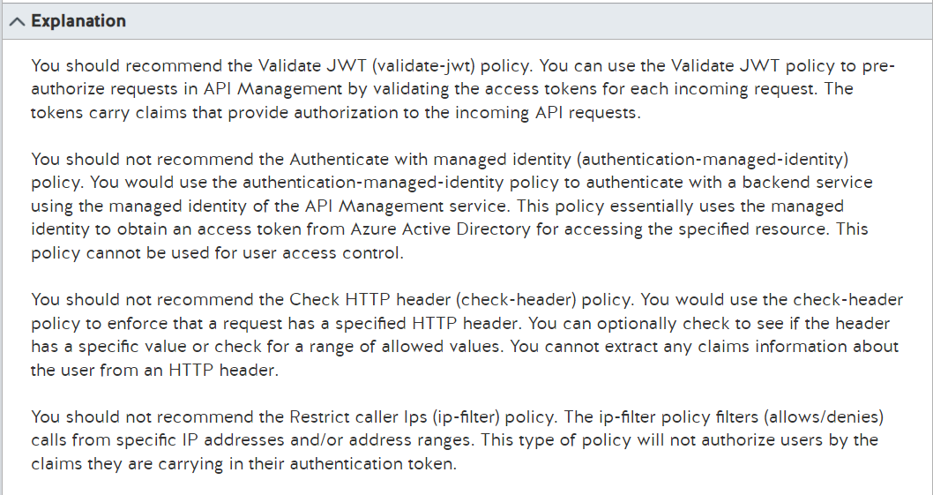

<https://docs.microsoft.com/en-us/azure/api-management/api-management-policies>

<https://docs.microsoft.com/en-us/azure/api-management/api-management-access-restriction-policies>

<https://docs.microsoft.com/en-us/azure/api-management/api-management-howto-protect-backend-with-aad>

<https://docs.microsoft.com/en-us/azure/api-management/api-management-authentication-policies>

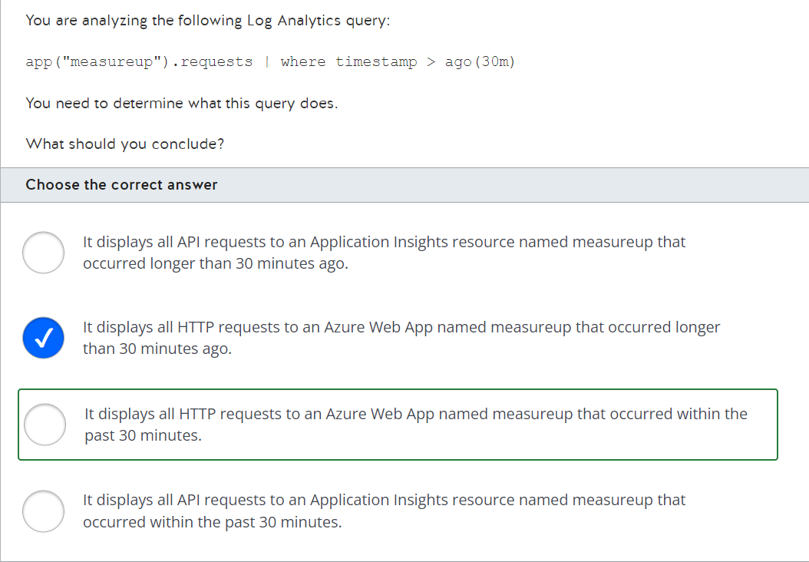

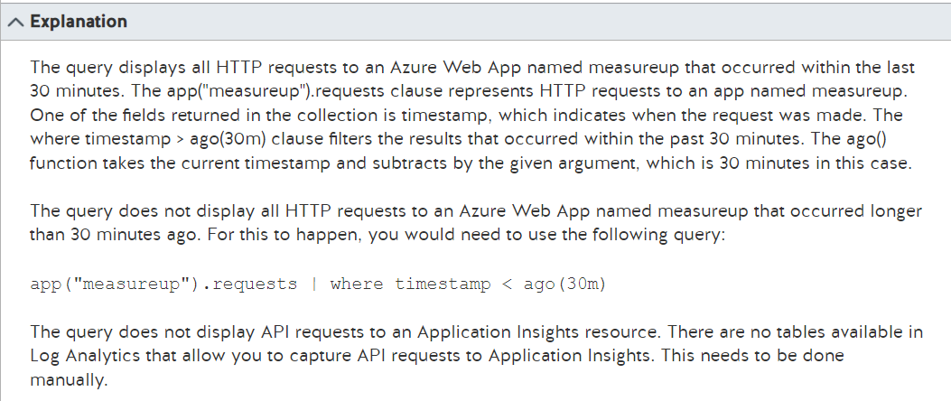

<https://docs.microsoft.com/en-us/azure/azure-monitor/logs/log-query-overview>

<https://docs.microsoft.com/en-us/azure/azure-monitor/app/javascript>

<https://docs.microsoft.com/en-us/azure/azure-monitor/logs/app-expression>

<https://docs.microsoft.com/en-us/azure/data-explorer/kusto/query/agofunction>

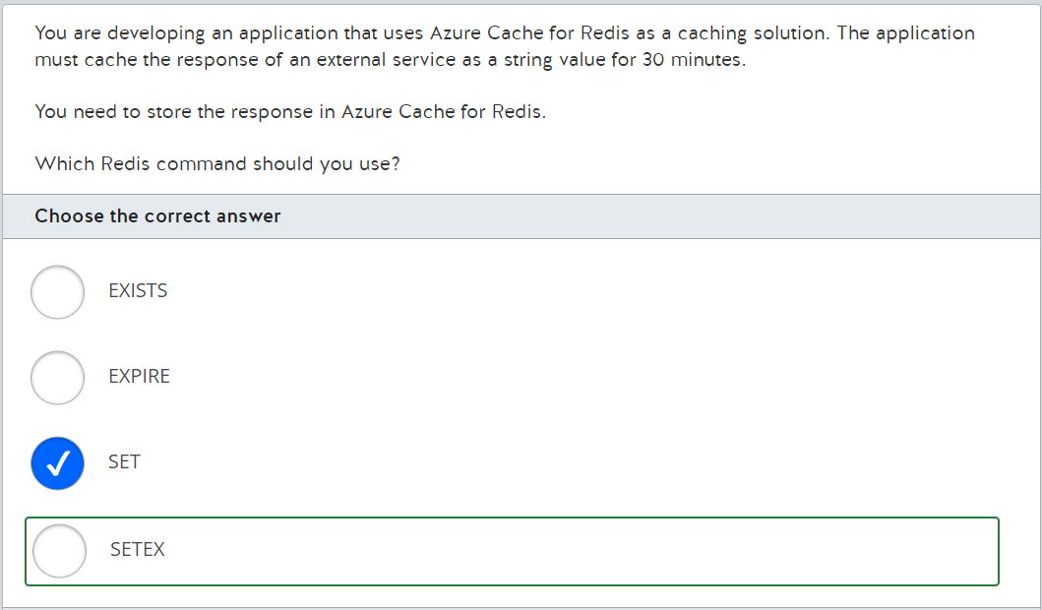

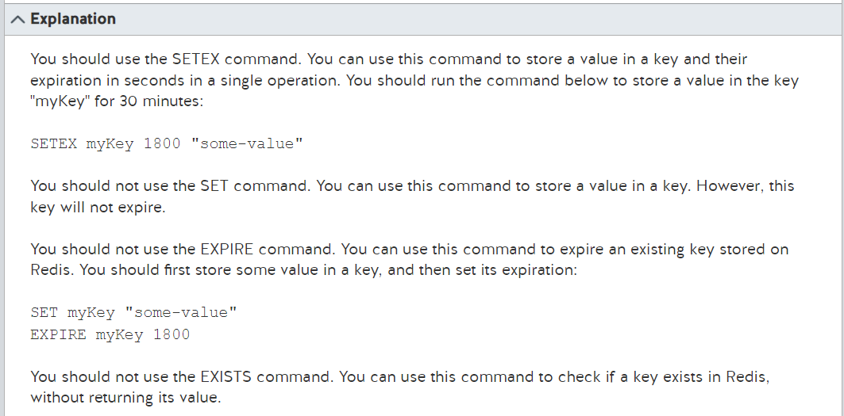

<https://docs.microsoft.com/en-us/azure/azure-cache-for-redis/cache-dotnet-core-quickstart>

<https://redis.io/commands/setex/>

<https://redis.io/commands/set/>

<https://redis.io/commands/expire/>

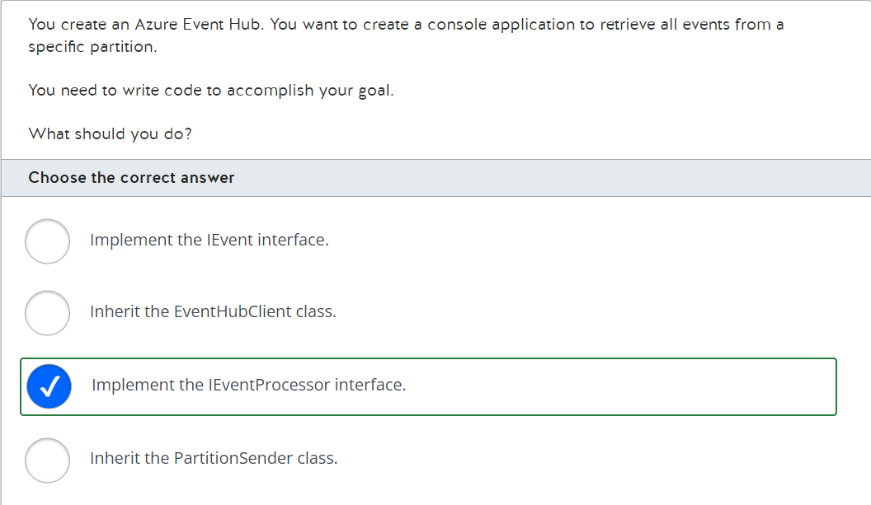

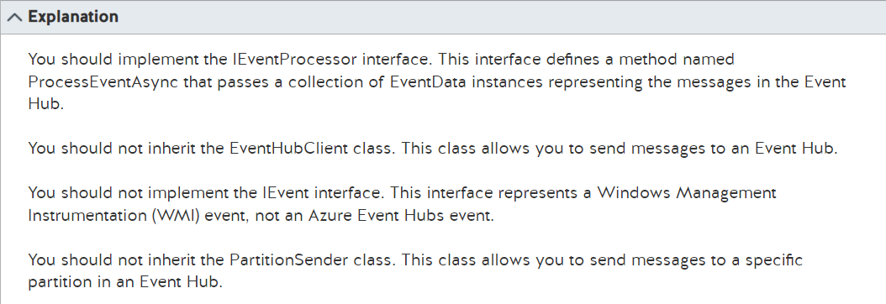

<https://docs.microsoft.com/en-us/azure/event-hubs/event-hubs-dotnet-standard-getstarted-send>

<https://docs.microsoft.com/en-us/dotnet/api/microsoft.azure.eventhubs.partitionsender.sendasync?view=azure-dotnet>

<https://docs.microsoft.com/en-us/dotnet/api/system.management.instrumentation.ievent?view=netframework-4.8>

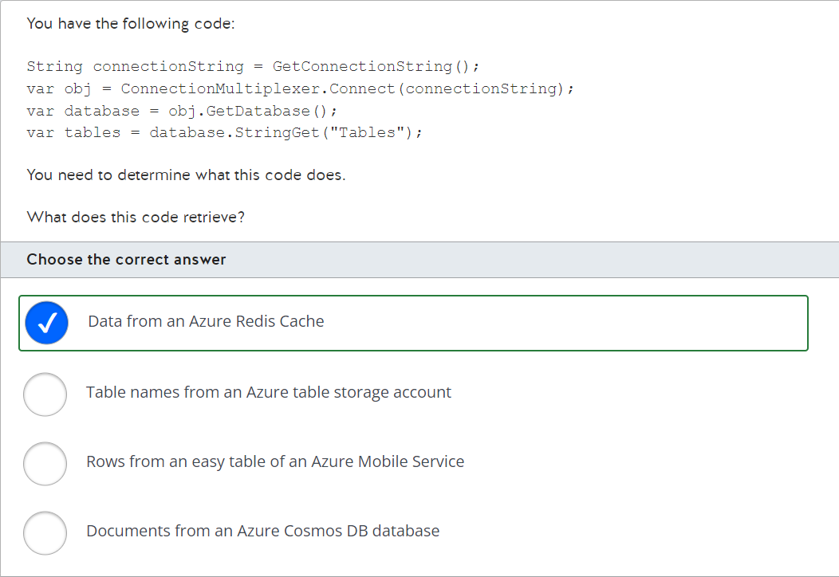

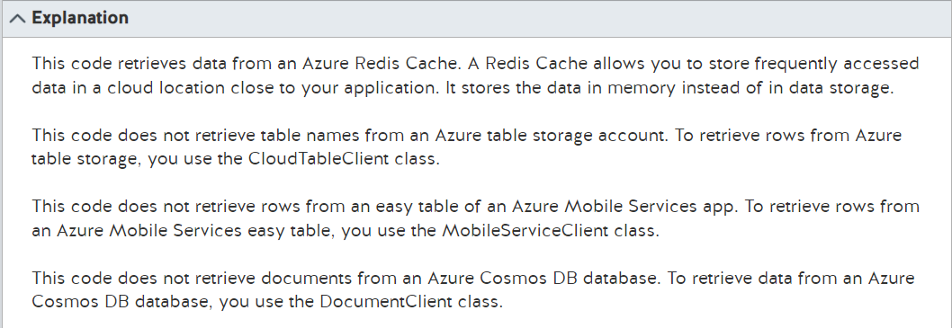

<https://docs.microsoft.com/en-us/azure/cosmos-db/sql/sql-api-get-started>

<https://docs.microsoft.com/en-us/azure/cosmos-db/table/create-table-dotnet?tabs=azure-portal%2Cvisual-studio>

<https://docs.microsoft.com/en-us/previous-versions/sandbox/gamedev/unity/samples/azure-mobile-apps-unity-racer>

<https://docs.microsoft.com/en-us/azure/azure-cache-for-redis/cache-dotnet-core-quickstart>

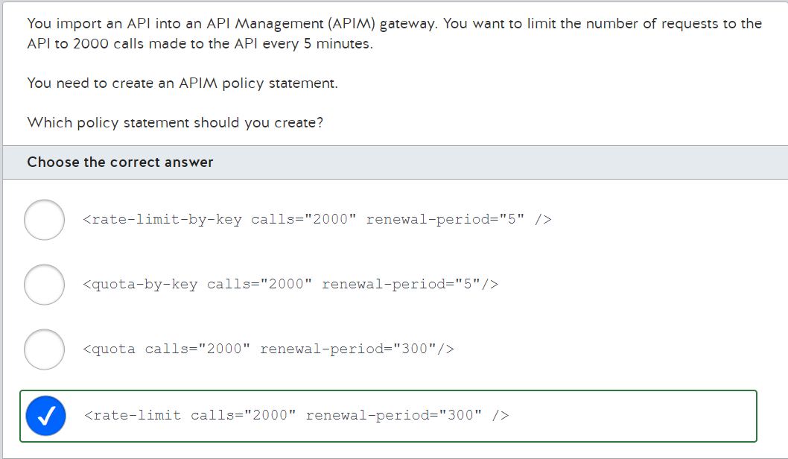

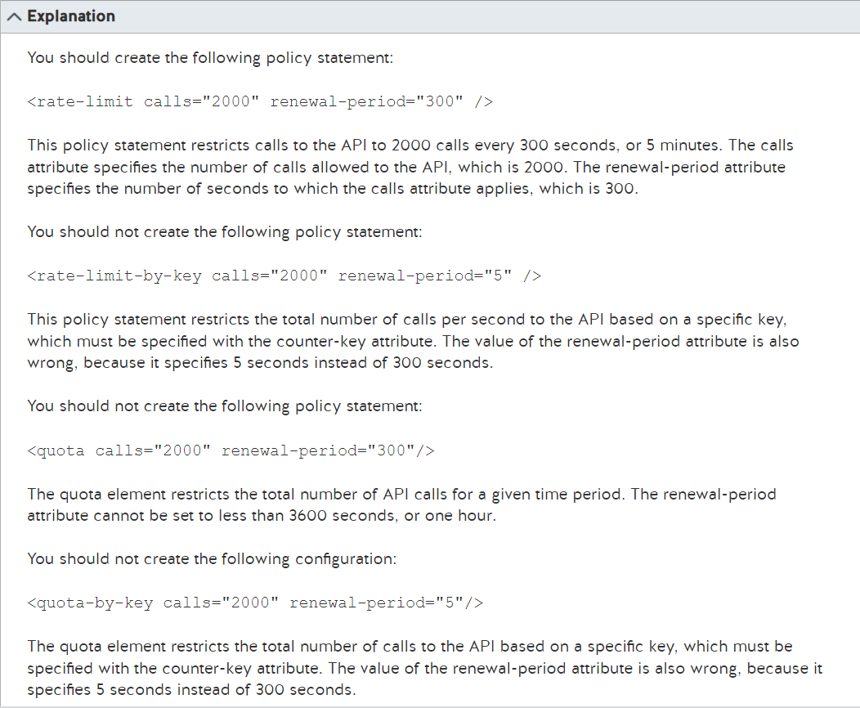

<https://docs.microsoft.com/en-us/azure/api-management/api-management-access-restriction-policies>

<https://docs.microsoft.com/en-us/azure/api-management/api-management-sample-flexible-throttling>

<https://docs.microsoft.com/en-us/azure/api-management/transform-api>

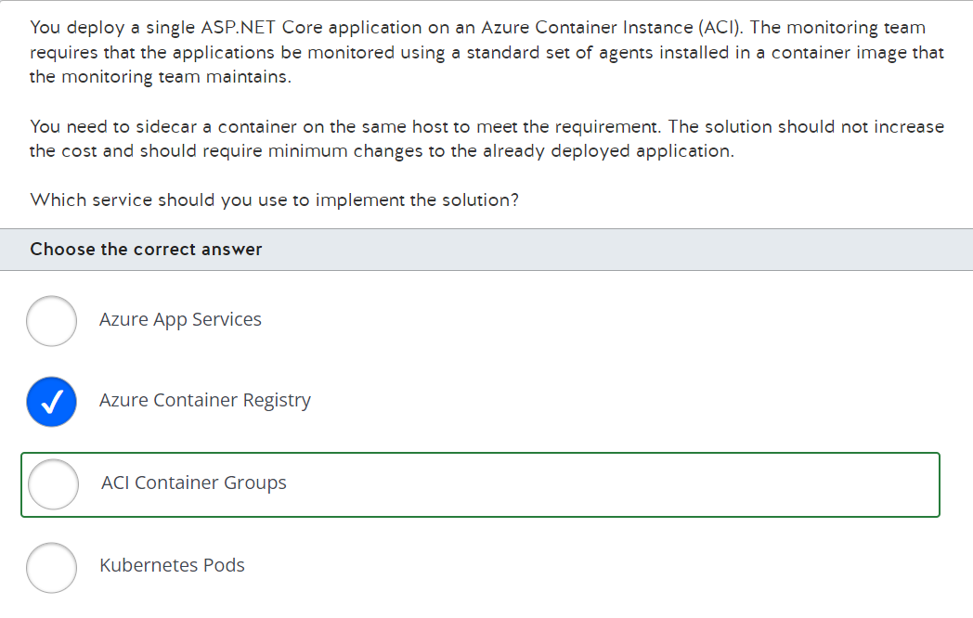

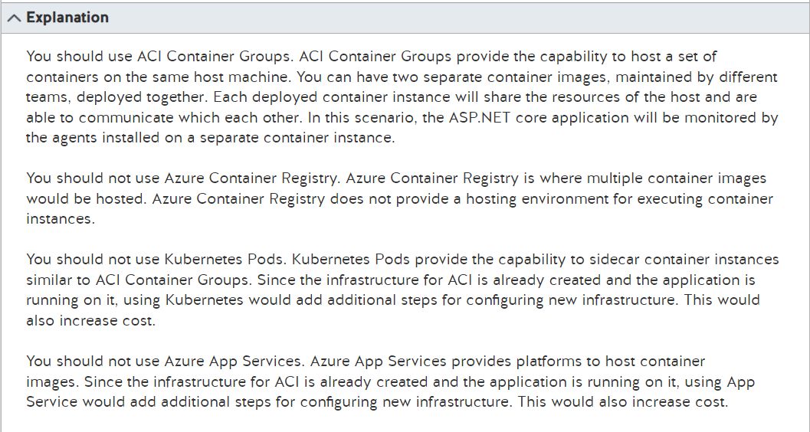

<https://docs.microsoft.com/en-us/azure/container-instances/container-instances-container-groups>

<https://kubernetes.io/docs/concepts/workloads/pods/>

<https://docs.microsoft.com/en-us/azure/container-instances/container-instances-multi-container-group>

<https://docs.microsoft.com/en-us/azure/container-registry/container-registry-intro>

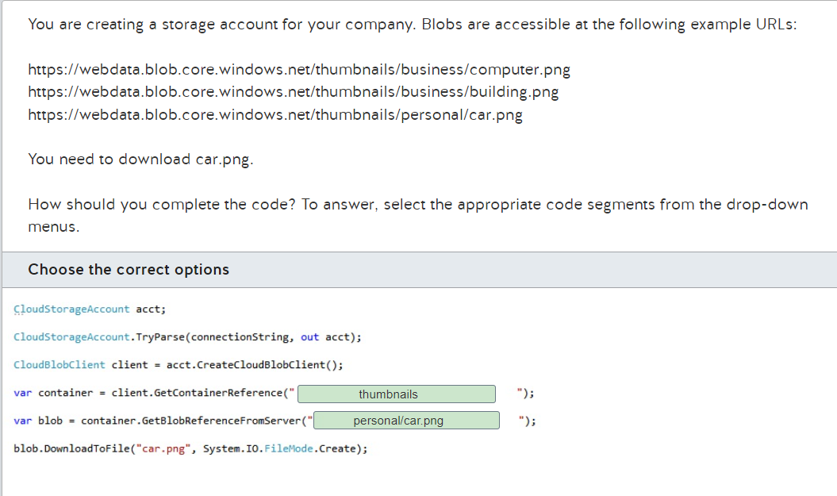

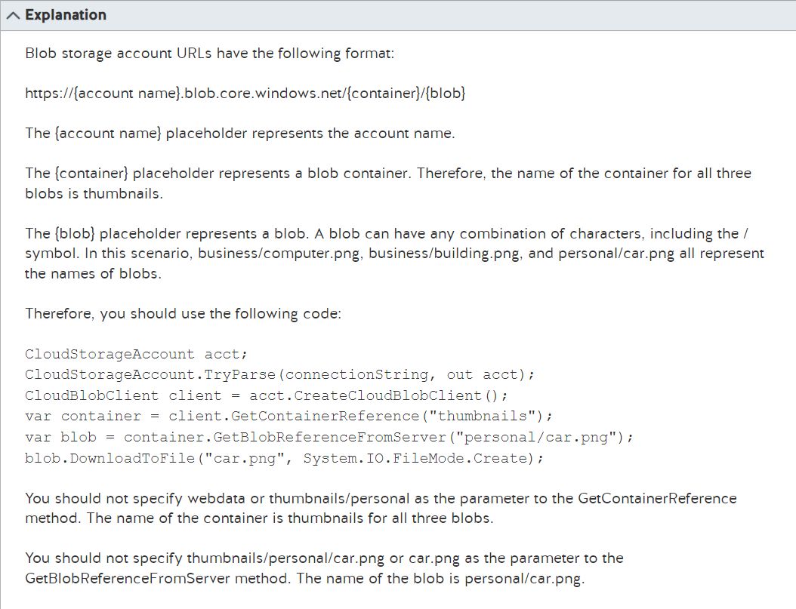

<https://docs.microsoft.com/en-us/rest/api/storageservices/naming-and-referencing-containers--blobs--and-metadata>

<https://docs.microsoft.com/en-us/azure/storage/blobs/storage-quickstart-blobs-dotnet?tabs=environment-variable-windows>

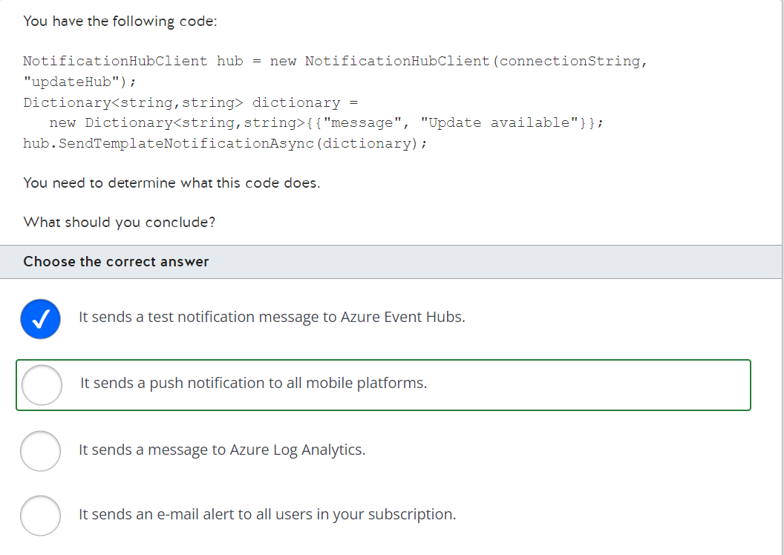

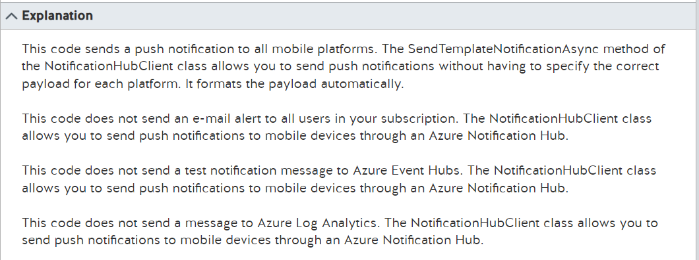

<https://docs.microsoft.com/en-us/azure/notification-hubs/notification-hubs-aspnet-cross-platform-notification>

<https://docs.microsoft.com/en-us/previous-versions/azure/azure-services/jj927170(v=azure.100)>

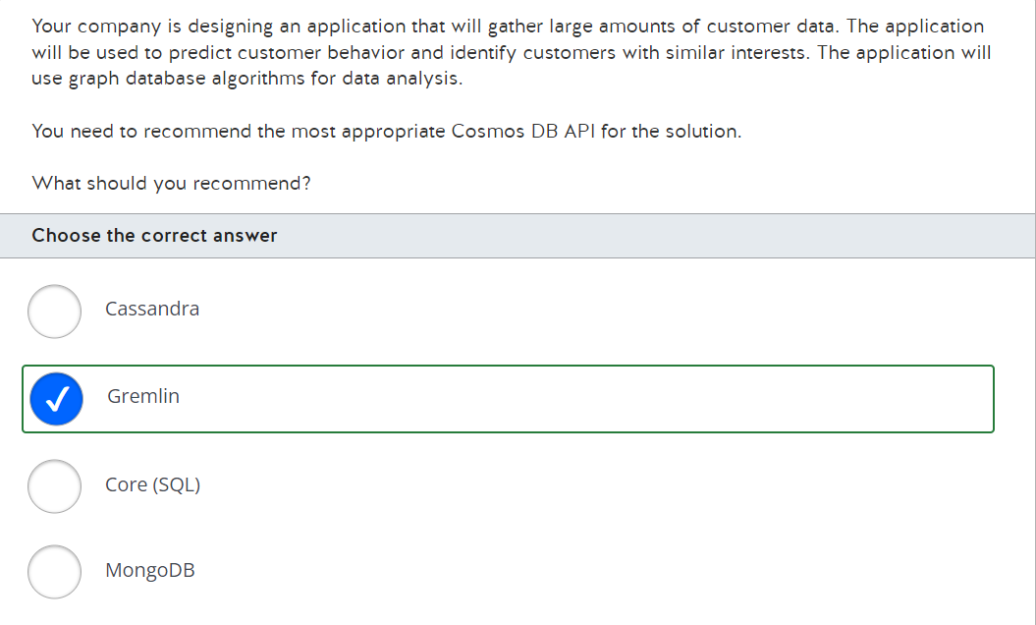

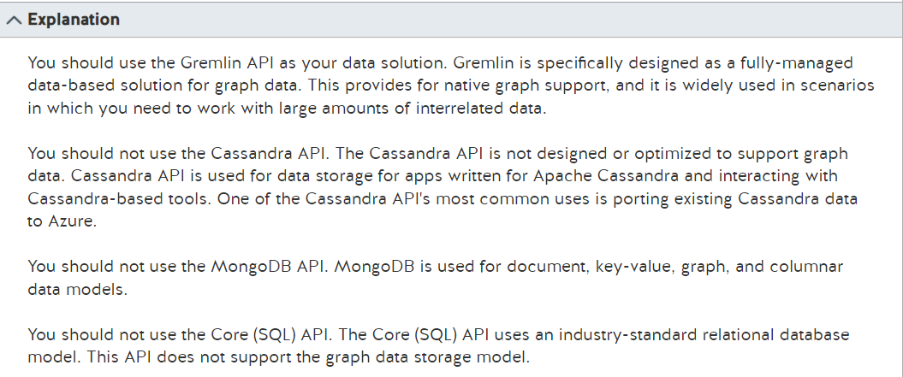

<https://docs.microsoft.com/en-us/azure/cosmos-db/graph/graph-introduction>

<https://docs.microsoft.com/en-us/azure/cosmos-db/relational-nosql>

<https://docs.microsoft.com/en-us/learn/modules/choose-api-for-cosmos-db/3-analyze-the-decision-criteria>

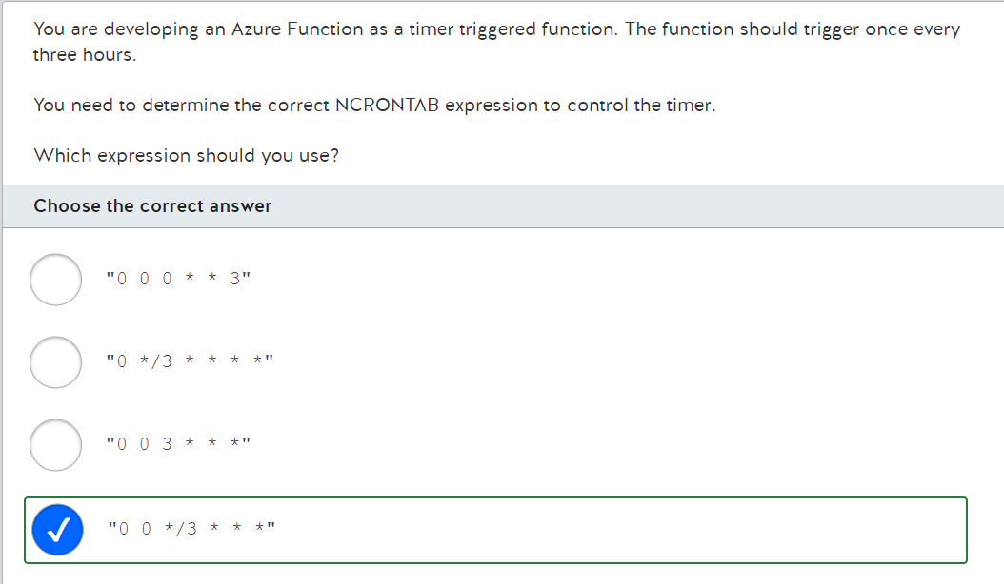

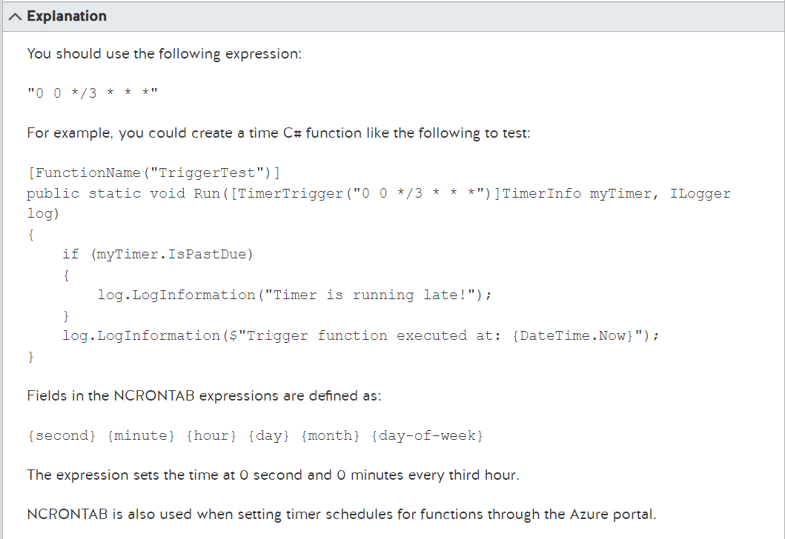

<https://docs.microsoft.com/en-us/azure/azure-functions/functions-create-scheduled-function>

<https://docs.microsoft.com/en-us/azure/azure-functions/functions-bindings-timer?tabs=in-process&pivots=programming-language-csharp>

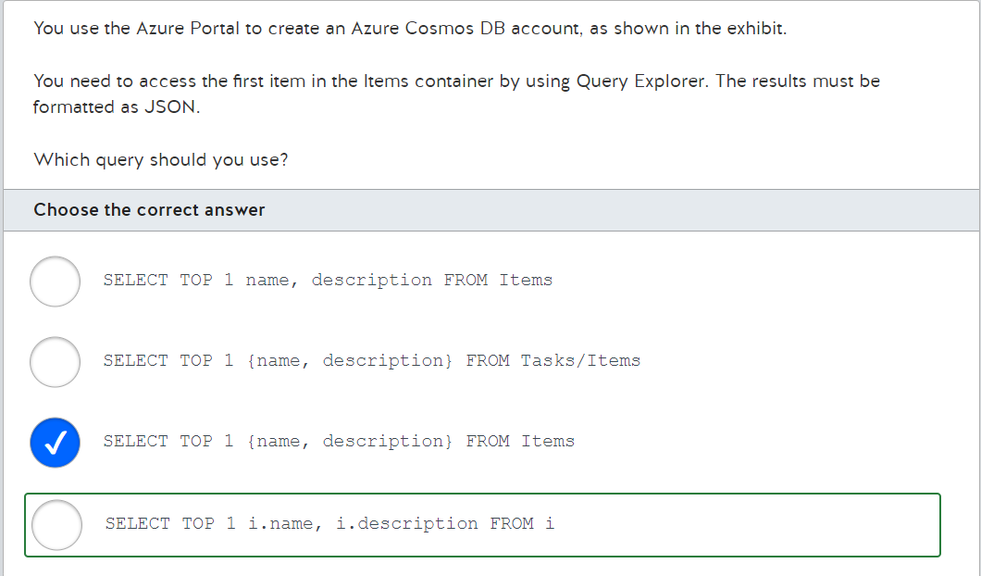

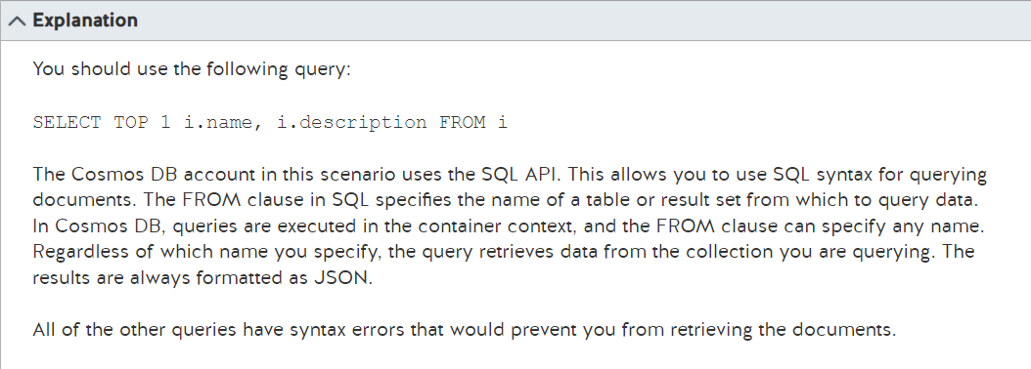

<https://docs.microsoft.com/en-us/azure/cosmos-db/sql/sql-query-getting-started>

<https://docs.microsoft.com/en-us/azure/cosmos-db/sql/sql-query-from>

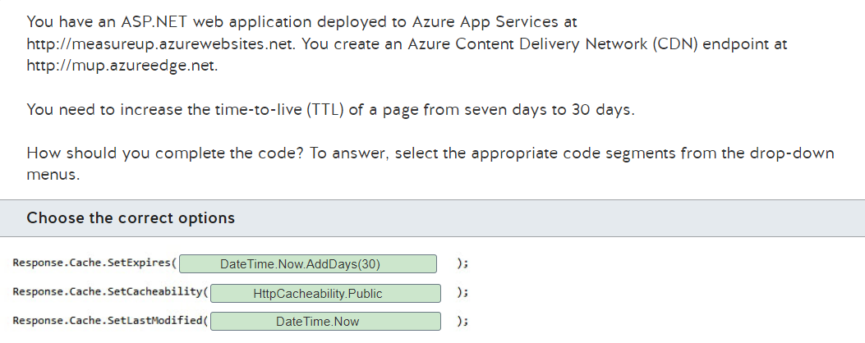

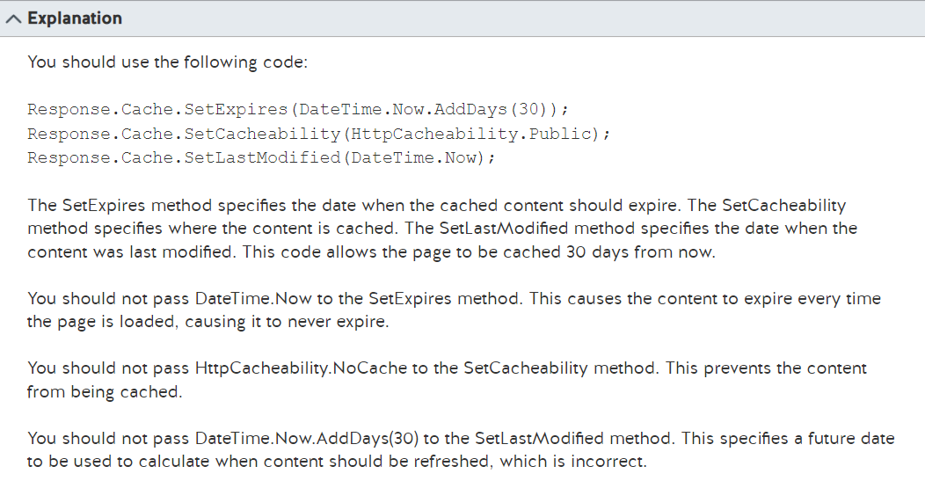

<https://docs.microsoft.com/en-us/azure/cdn/cdn-manage-expiration-of-cloud-service-content>

<https://docs.microsoft.com/en-us/dotnet/api/system.web.httpcacheability?view=netframework-4.8>

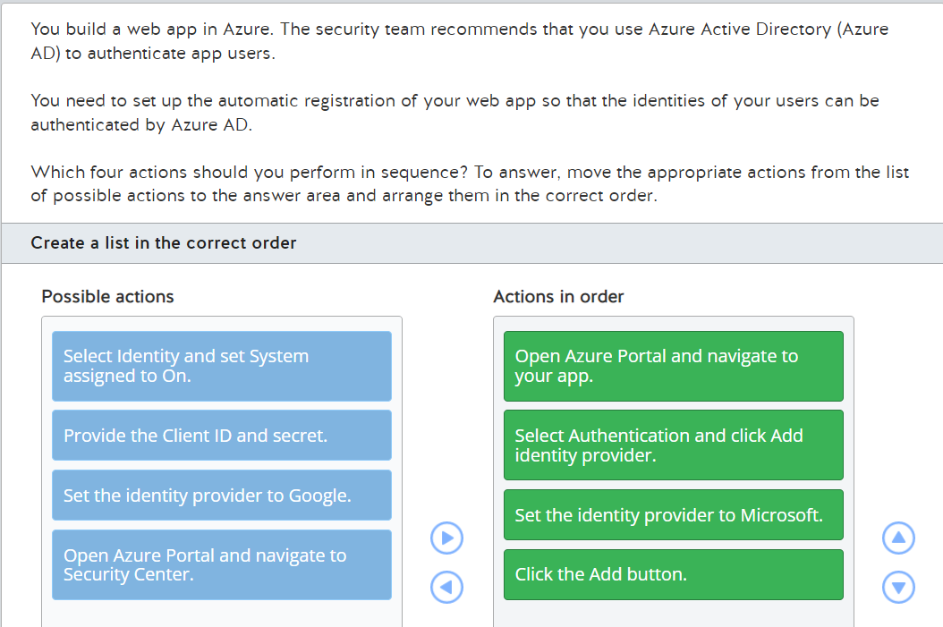

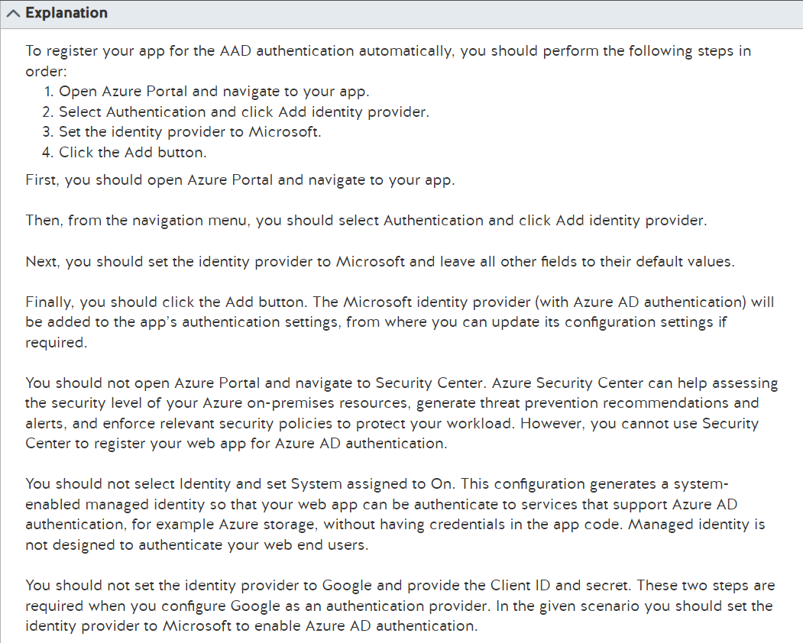

<https://docs.microsoft.com/en-us/azure/app-service/configure-authentication-provider-aad>

<https://docs.microsoft.com/en-us/azure/defender-for-cloud/defender-for-cloud-introduction>

<https://docs.microsoft.com/en-gb/azure/active-directory/managed-identities-azure-resources/overview>

<https://docs.microsoft.com/en-us/azure/app-service/configure-authentication-provider-google>

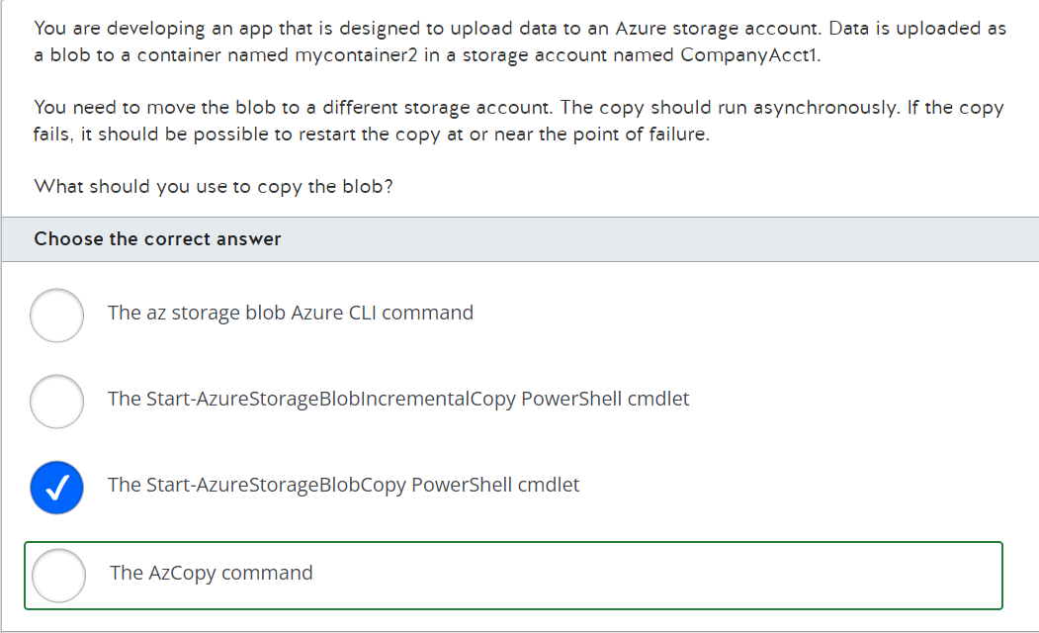

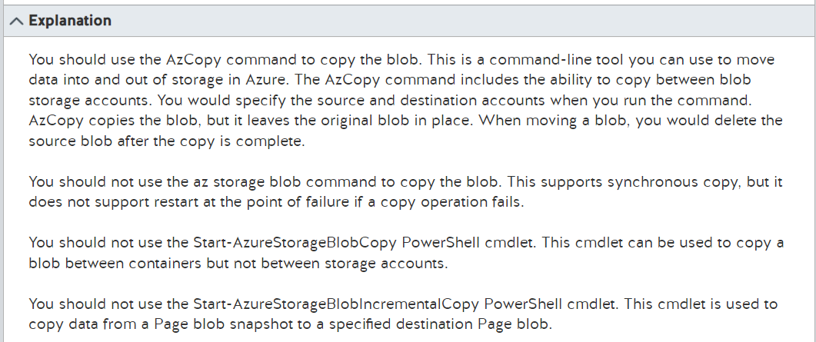

<https://docs.microsoft.com/en-us/powershell/module/azure.storage/start-azurestorageblobcopy?view=azurermps-6.13.0>

<https://docs.microsoft.com/en-us/powershell/module/azure.storage/start-azurestorageblobincrementalcopy?view=azurermps-6.13.0>

<https://docs.microsoft.com/en-us/azure/storage/common/storage-ref-azcopy>

<https://docs.microsoft.com/en-us/azure/storage/common/storage-use-azcopy-v10>

<https://docs.microsoft.com/en-us/learn/modules/copy-blobs-from-command-line-and-code/2-choosing-a-tool-and-strategy>

<https://docs.microsoft.com/en-us/learn/modules/copy-blobs-from-command-line-and-code/3-move-blobs-using-cli>

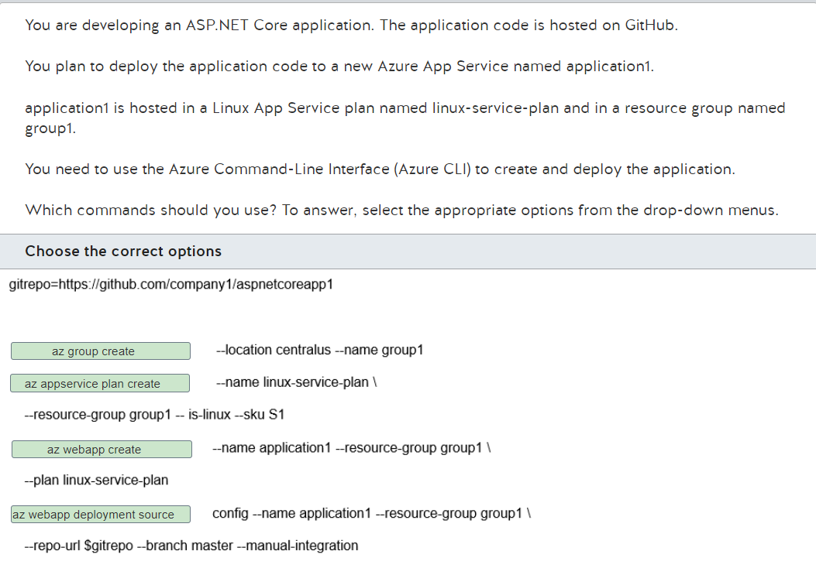

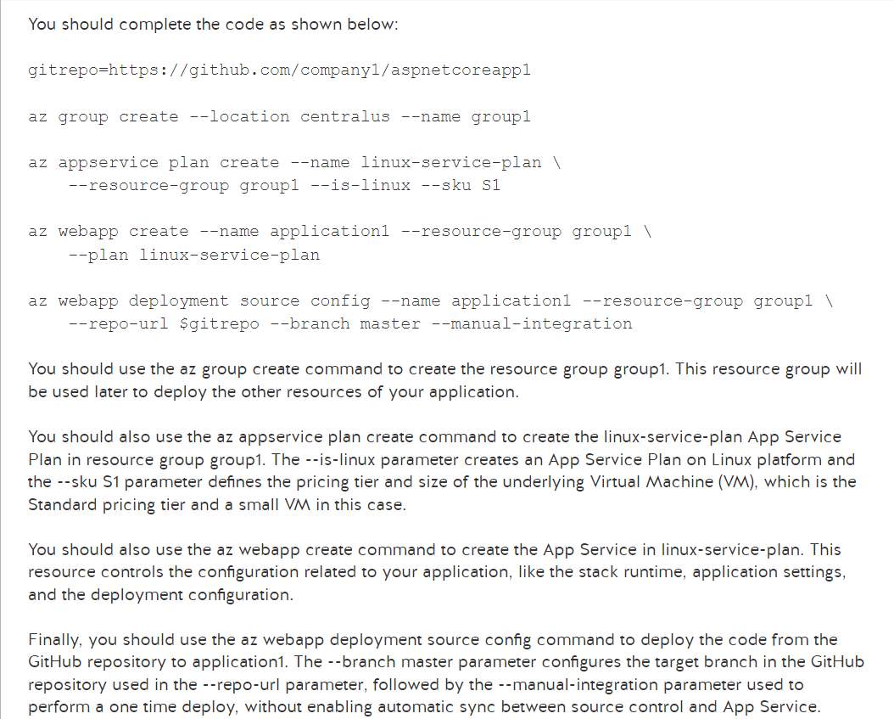

<https://docs.microsoft.com/en-us/azure/app-service/scripts/cli-deploy-github>

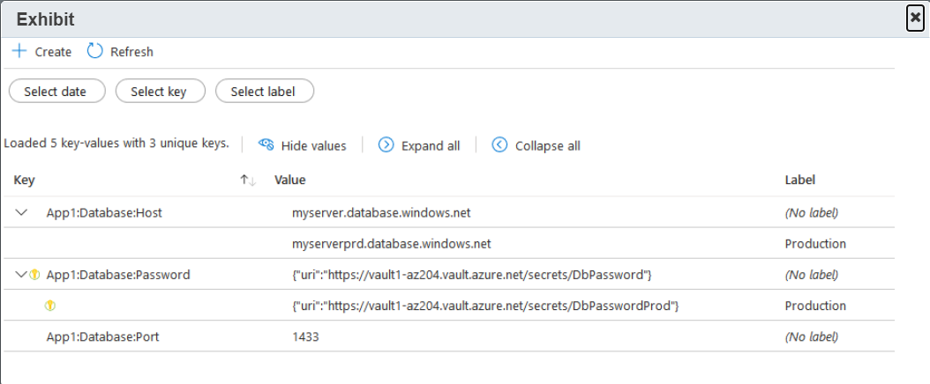

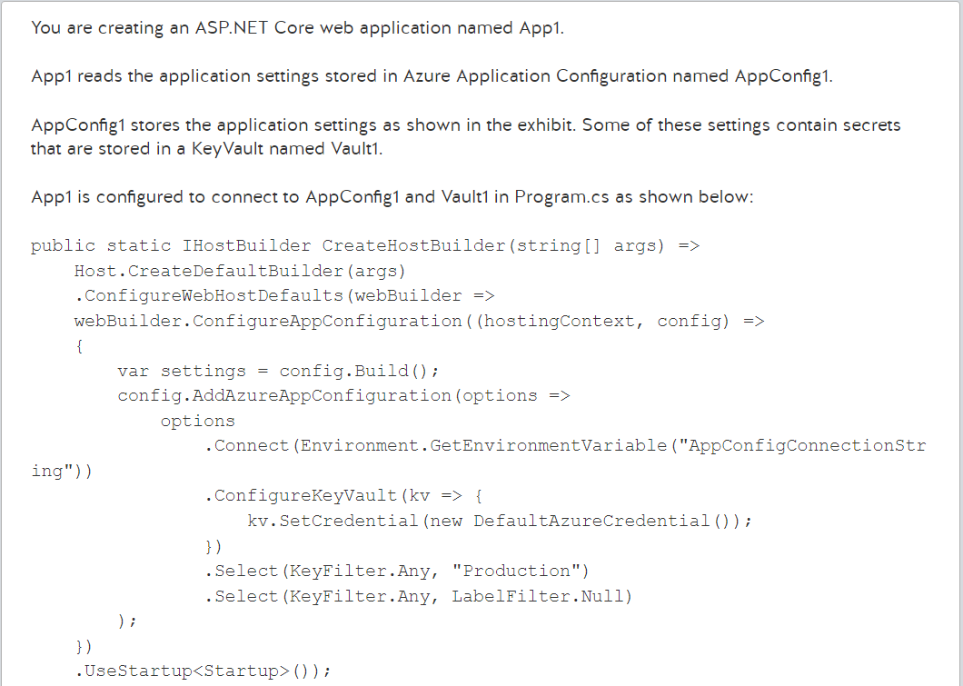

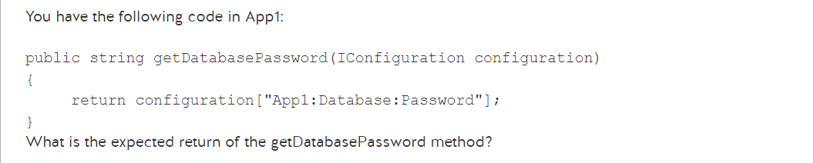

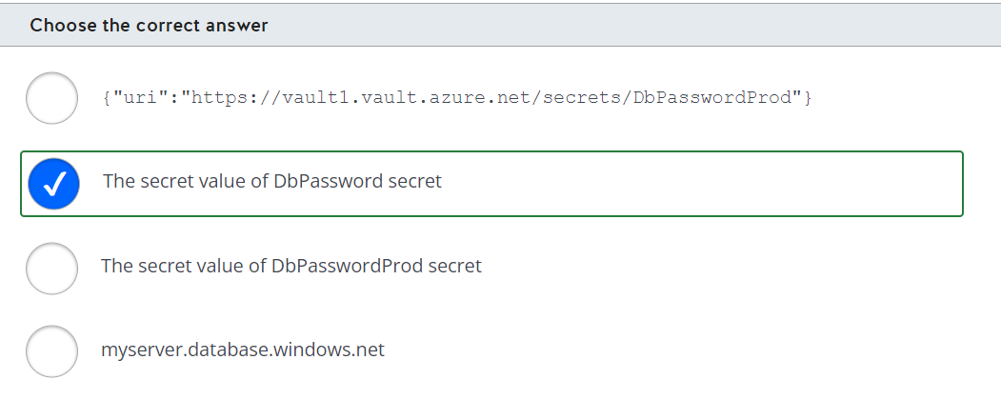

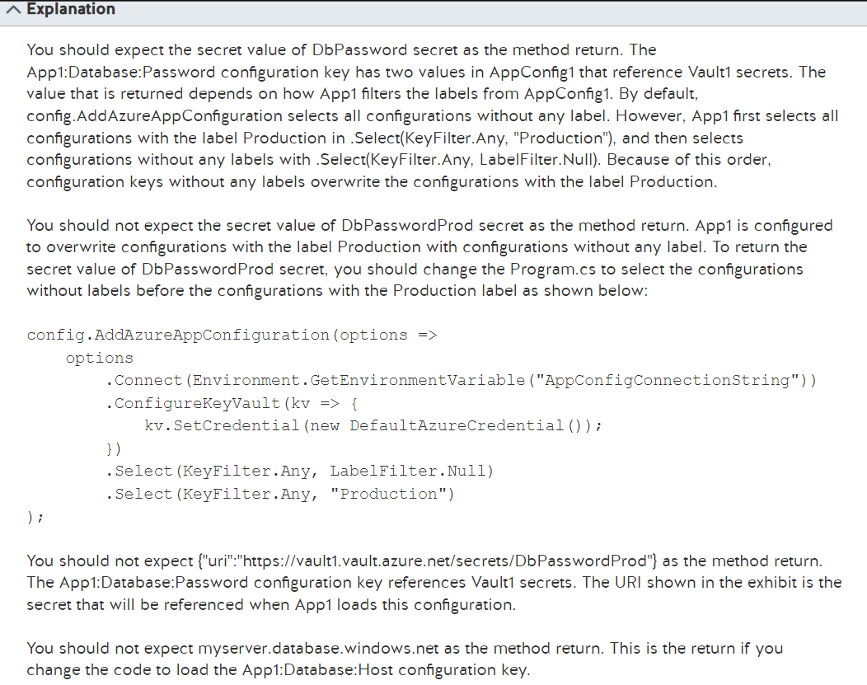

<https://docs.microsoft.com/en-us/azure/azure-app-configuration/use-key-vault-references-dotnet-core?tabs=core5x>

<https://docs.microsoft.com/en-us/azure/azure-app-configuration/howto-labels-aspnet-core?tabs=core5x>

<https://docs.microsoft.com/en-us/azure/azure-app-configuration/concept-key-value>

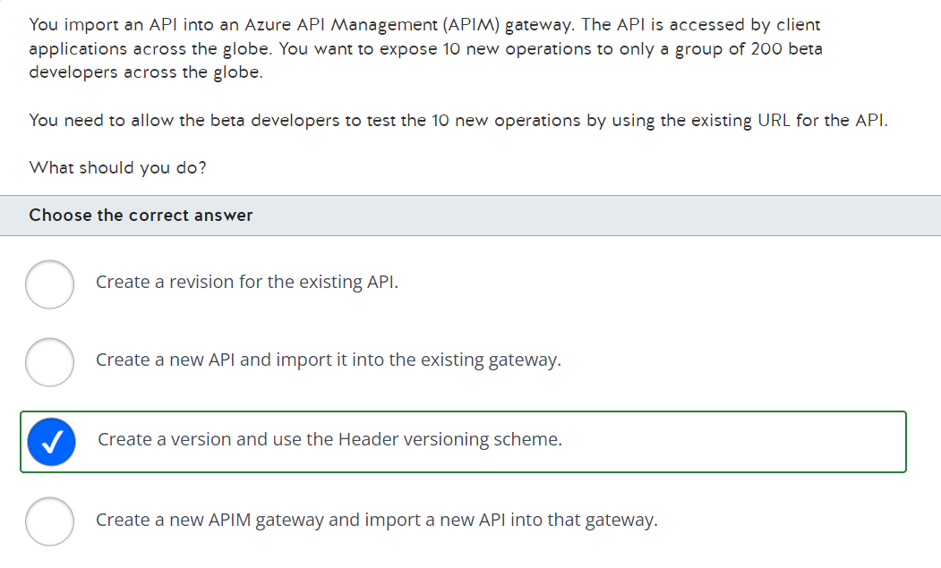

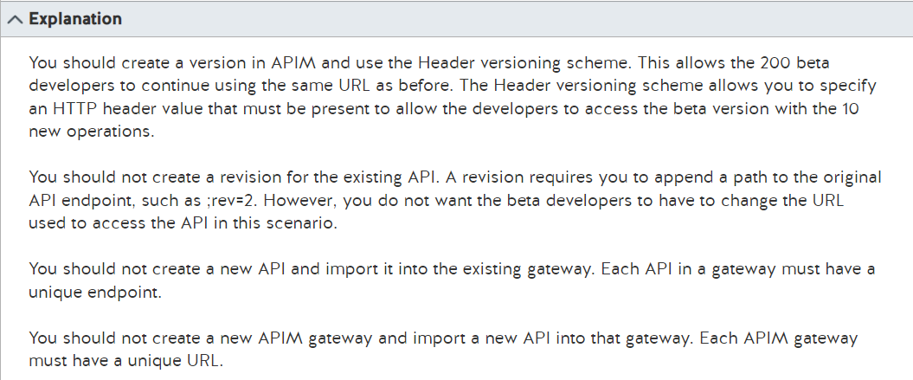

<https://docs.microsoft.com/en-us/azure/api-management/api-management-get-started-publish-versions>

<https://docs.microsoft.com/en-us/azure/api-management/api-management-get-started-revise-api?tabs=azure-portal>

<https://docs.microsoft.com/en-us/azure/api-management/api-management-key-concepts>

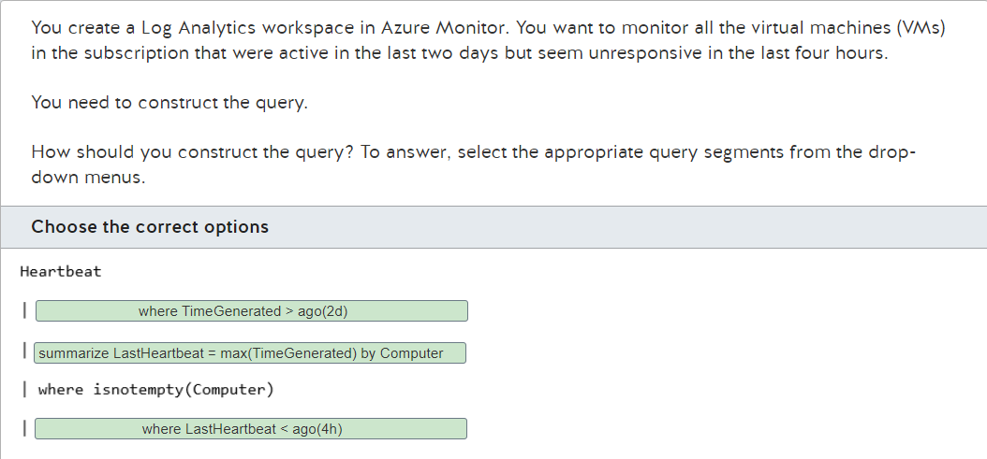

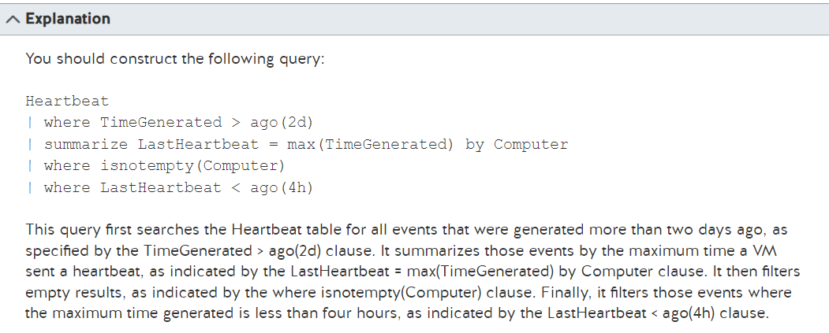

<https://docs.microsoft.com/en-us/azure/data-explorer/kusto/query/samples?pivots=azuremonitor#find-stale-computer>

<https://docs.microsoft.com/en-us/azure/azure-monitor/logs/log-query-overview>

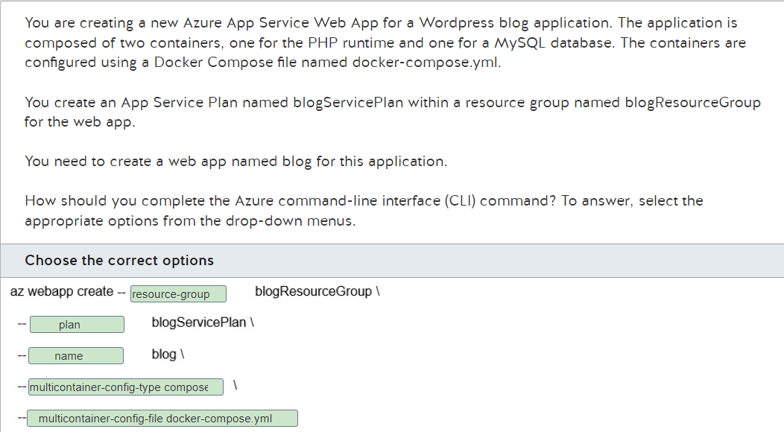

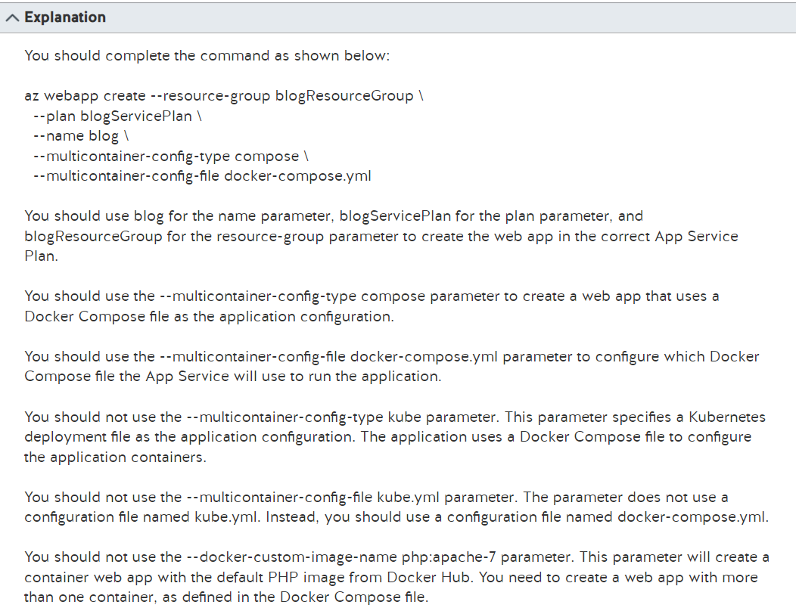

<https://docs.microsoft.com/en-us/azure/app-service/tutorial-multi-container-app>

<https://docs.microsoft.com/en-us/cli/azure/webapp?view=azure-cli-latest>

<https://kubernetes.io/docs/concepts/overview/working-with-objects/kubernetes-objects/>

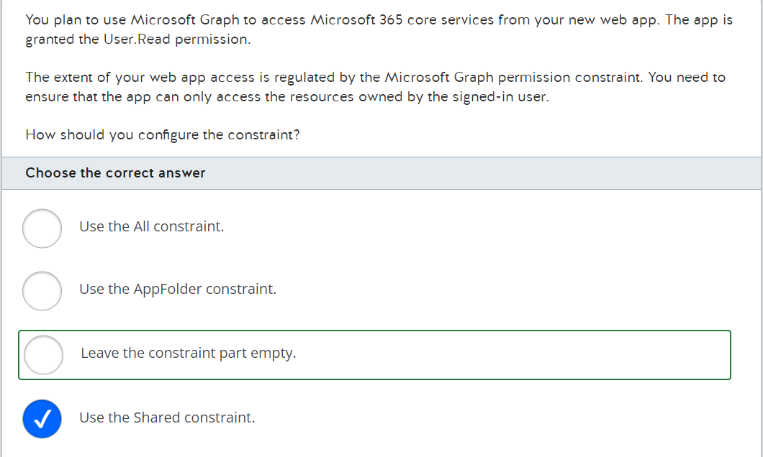

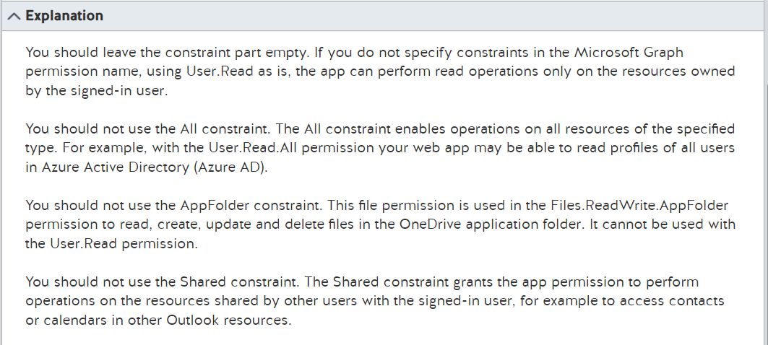

<https://docs.microsoft.com/en-us/graph/auth/>

<https://docs.microsoft.com/en-us/graph/permissions-reference>

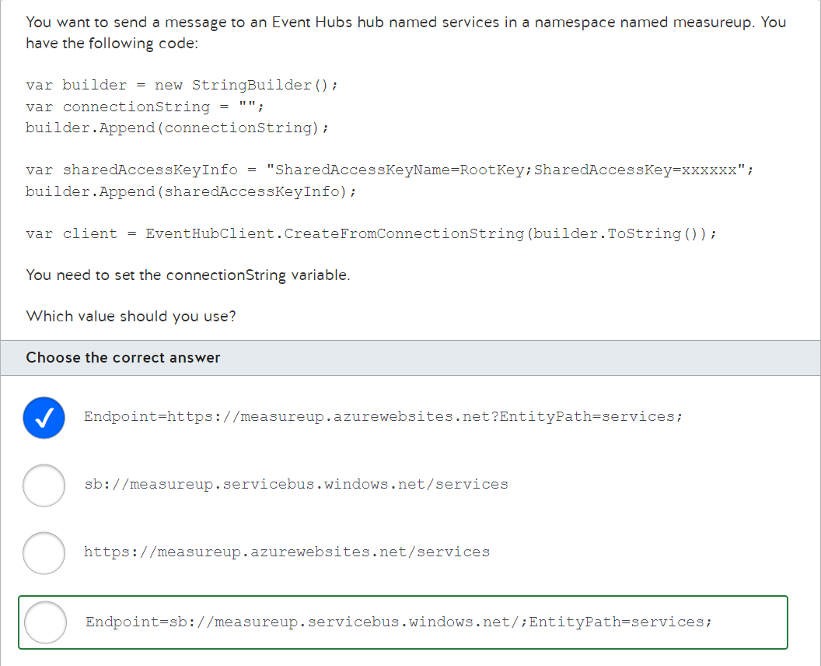

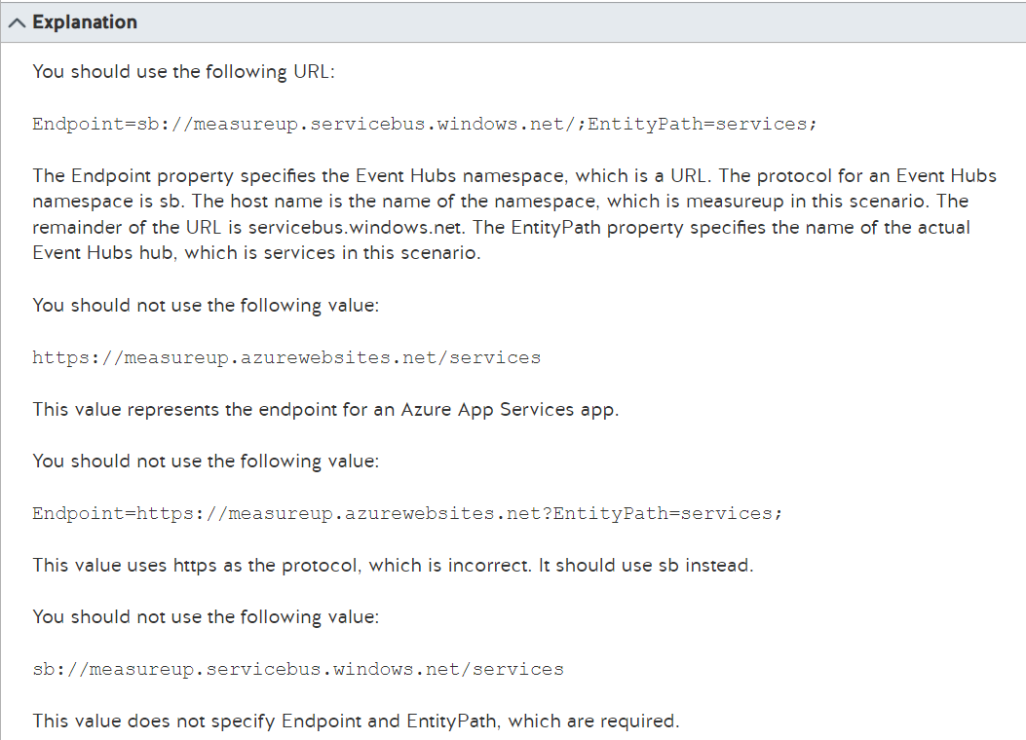

<https://docs.microsoft.com/en-us/azure/event-hubs/event-hubs-programming-guide>

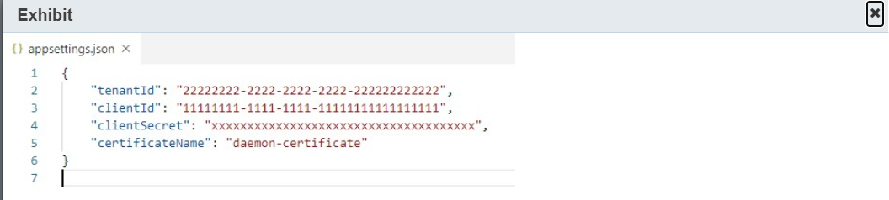

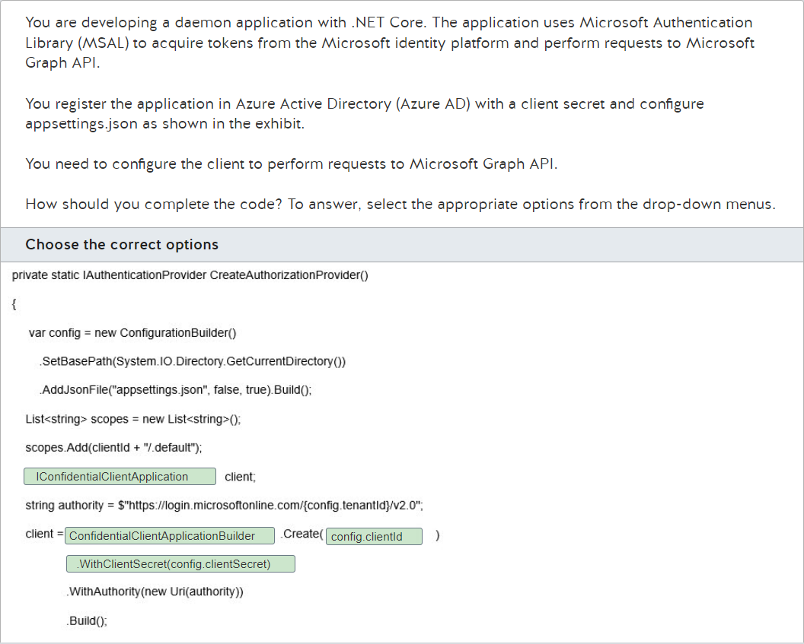

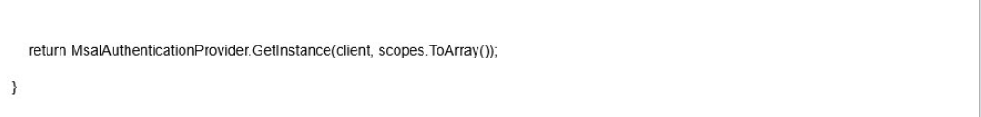

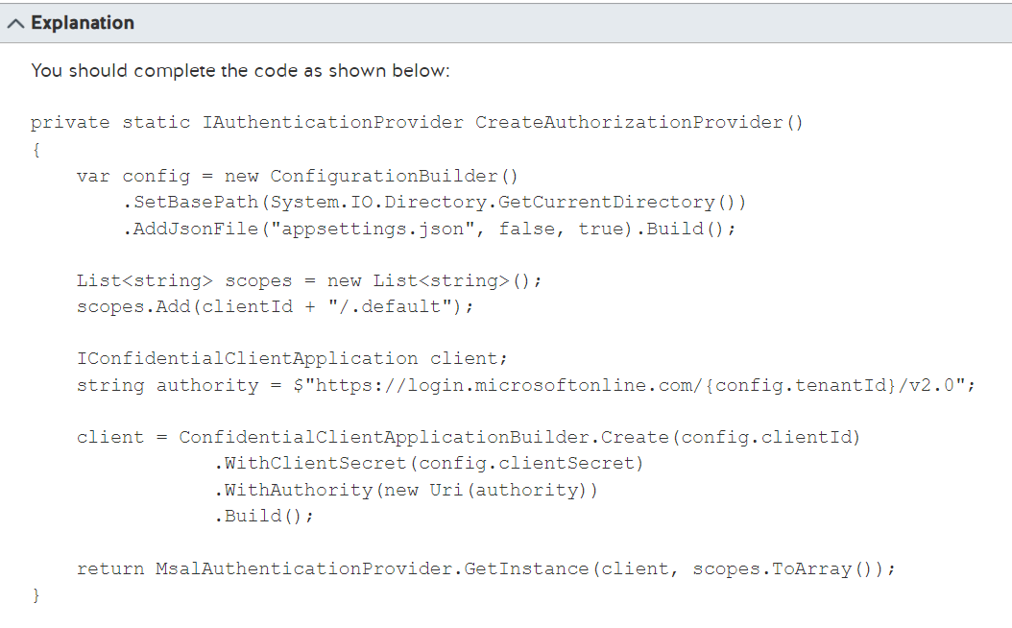

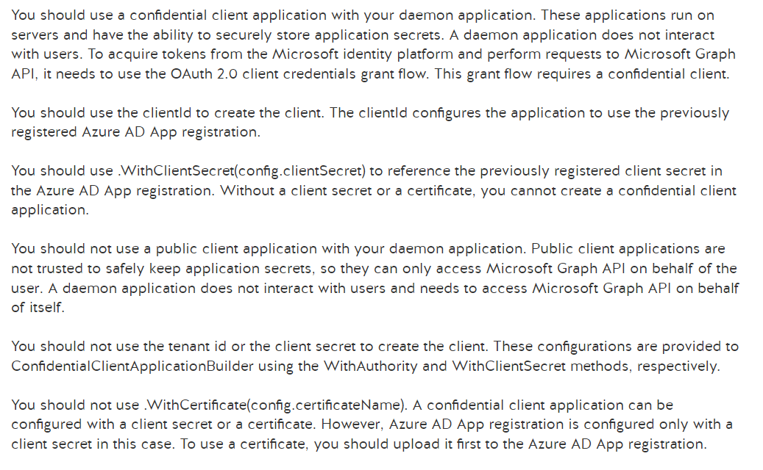

<https://docs.microsoft.com/en-us/azure/active-directory/develop/msal-overview>

<https://docs.microsoft.com/en-us/azure/active-directory/develop/scenario-daemon-overview>

<https://docs.microsoft.com/en-us/azure/active-directory/develop/v2-oauth2-client-creds-grant-flow>

<https://docs.microsoft.com/en-us/azure/active-directory/develop/msal-client-applications>

<https://docs.microsoft.com/en-us/learn/modules/identity-application-types/7-exercise-daemon-non-interactive-apps>

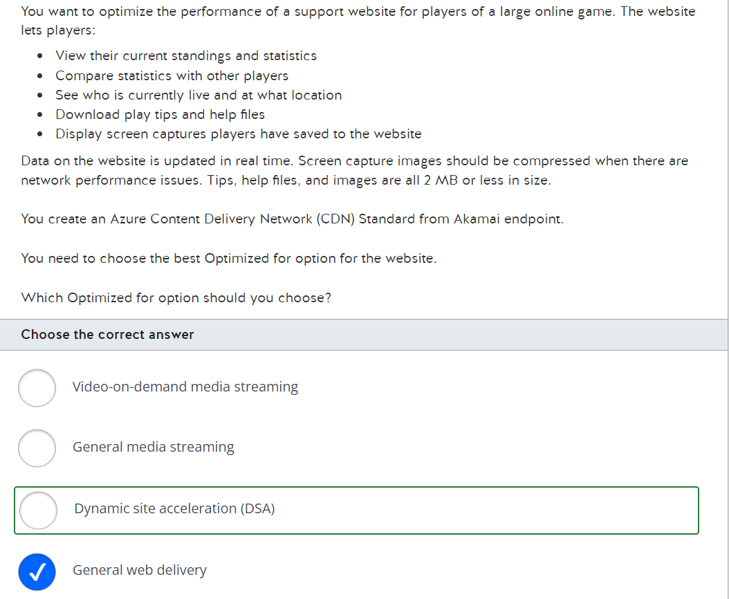

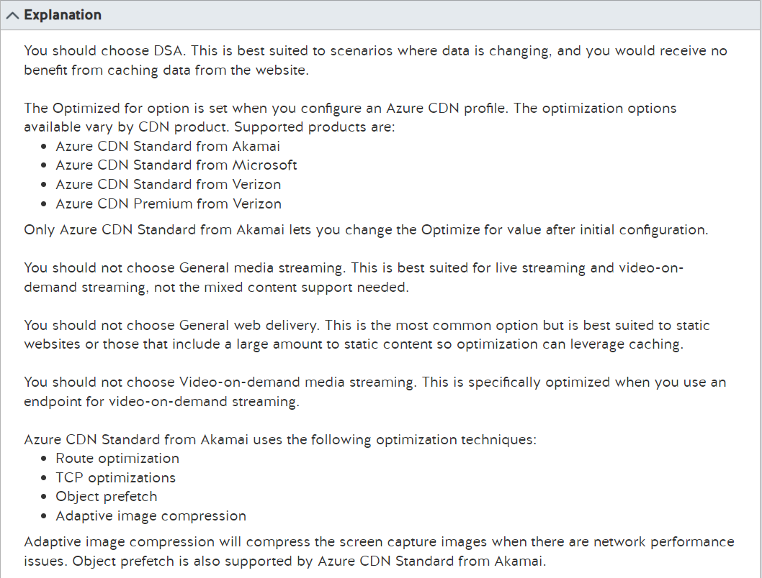

<https://docs.microsoft.com/en-us/azure/cdn/cdn-overview>

<https://docs.microsoft.com/en-us/azure/cdn/cdn-optimization-overview>

<https://docs.microsoft.com/en-us/azure/cdn/cdn-dynamic-site-acceleration>

<https://docs.microsoft.com/en-us/azure/cdn/cdn-features>

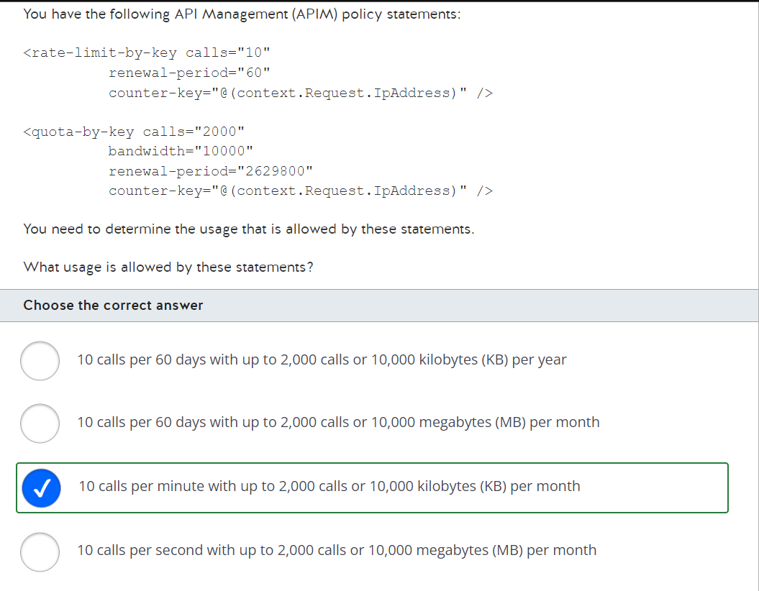

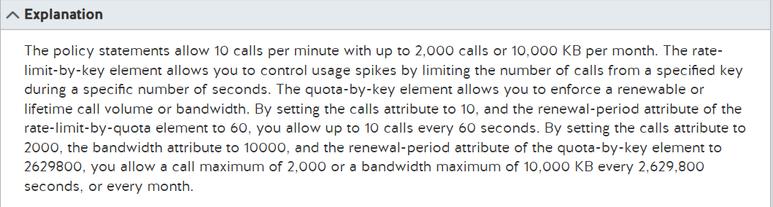

<https://docs.microsoft.com/en-us/azure/api-management/api-management-sample-flexible-throttling>

<https://docs.microsoft.com/en-us/azure/api-management/api-management-access-restriction-policies>

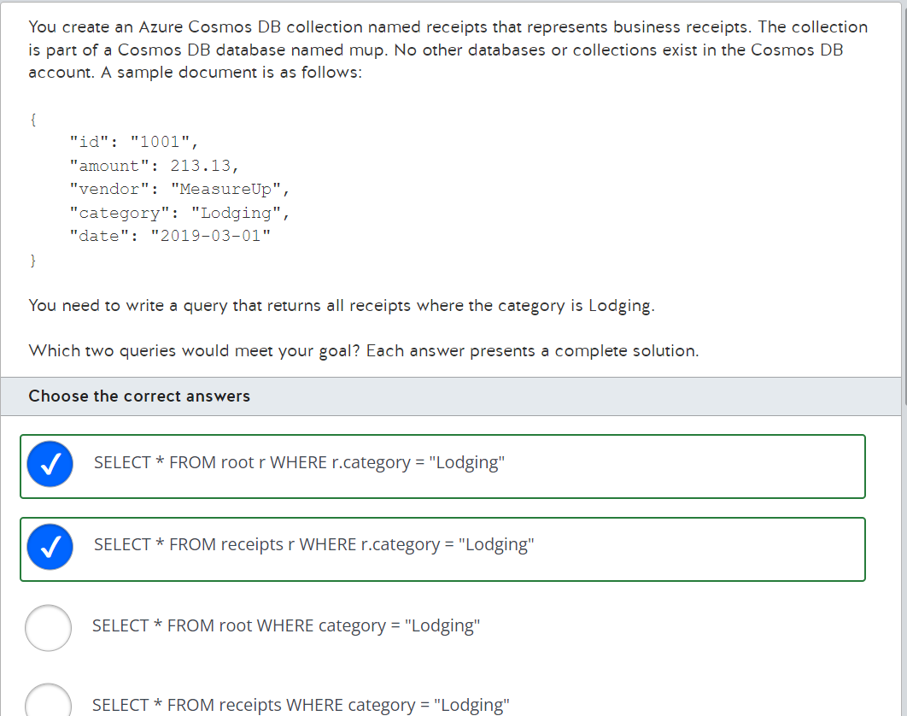

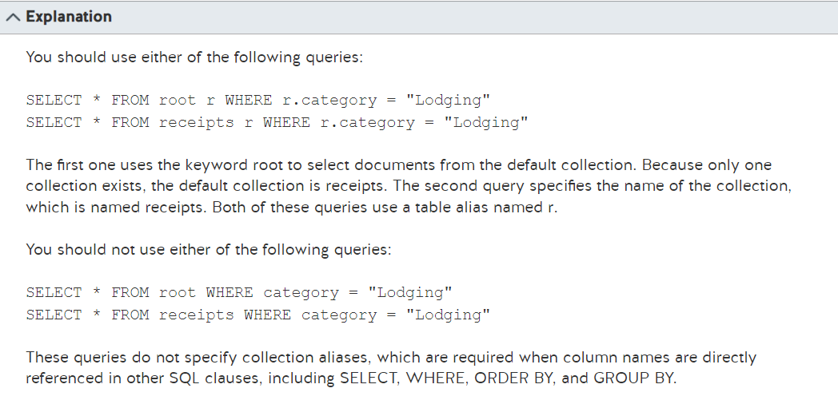

<https://docs.microsoft.com/en-us/azure/cosmos-db/sql/sql-query-getting-started>

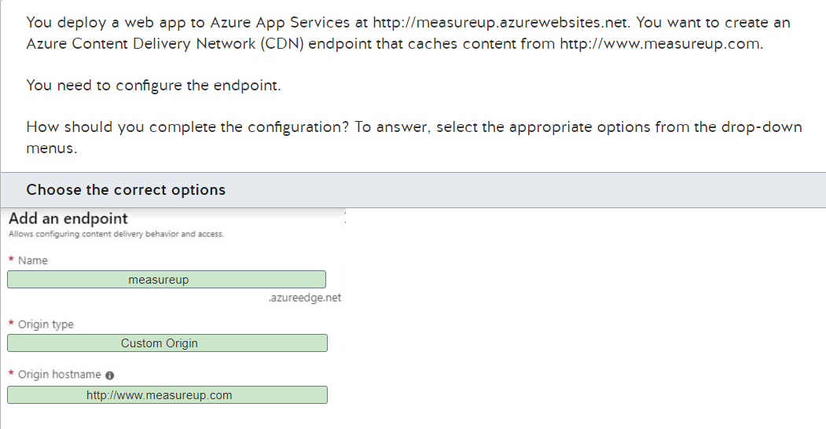

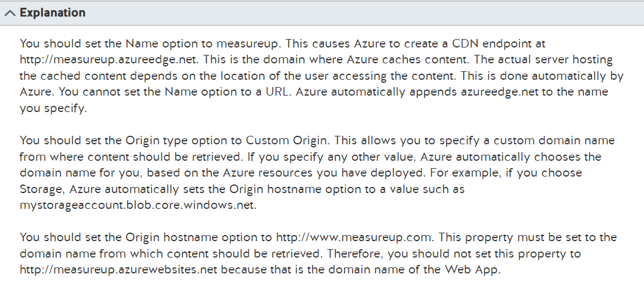

<https://docs.microsoft.com/en-us/azure/cdn/cdn-add-to-web-app>

#https://docs.microsoft.com/en-us/azure/cdn/cdn-overview

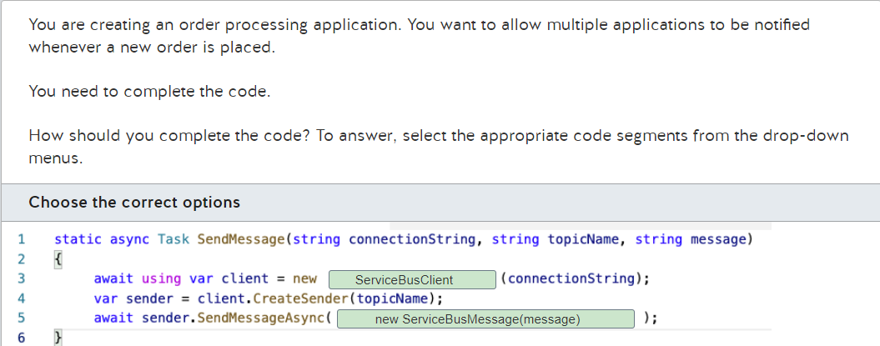

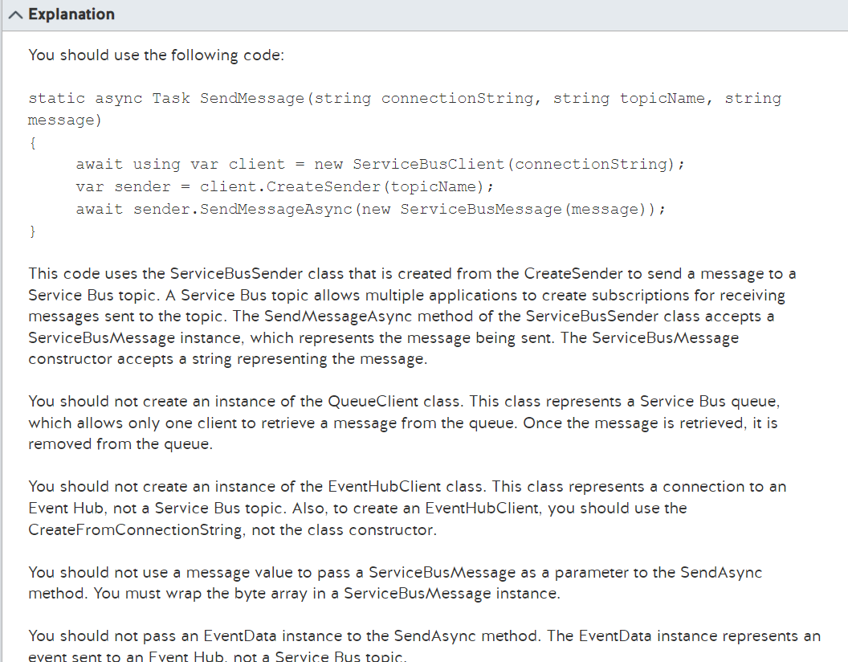

<https://docs.microsoft.com/en-us/azure/service-bus-messaging/service-bus-queues-topics-subscriptions>

<https://docs.microsoft.com/en-us/azure/service-bus-messaging/service-bus-dotnet-how-to-use-topics-subscriptions>

<https://docs.microsoft.com/en-us/azure/event-hubs/event-hubs-features>

<https://docs.microsoft.com/en-us/azure/event-hubs/event-hubs-programming-guide>

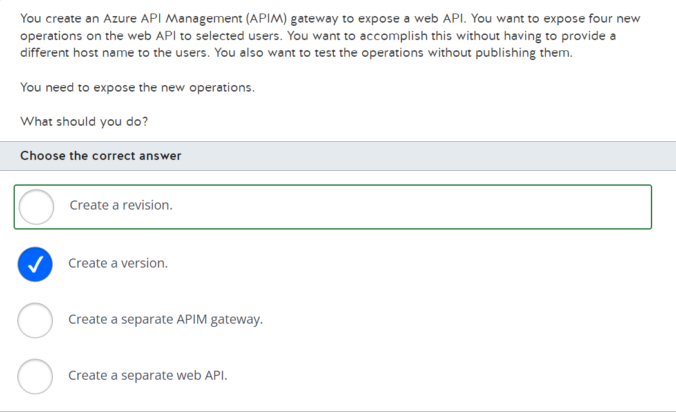

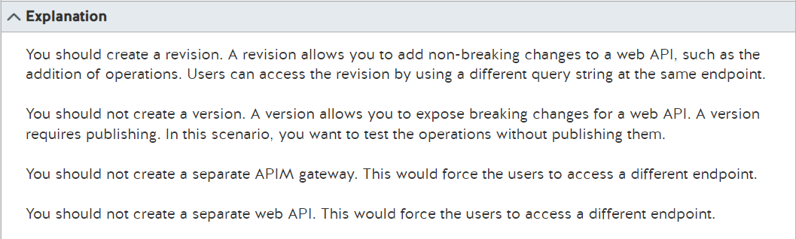

<https://docs.microsoft.com/en-us/azure/api-management/api-management-configuration-repository-git>

<https://docs.microsoft.com/en-us/azure/api-management/api-management-modify-content-layout>

<https://docs.microsoft.com/en-us/azure/api-management/api-management-howto-add-products?tabs=azure-portal>

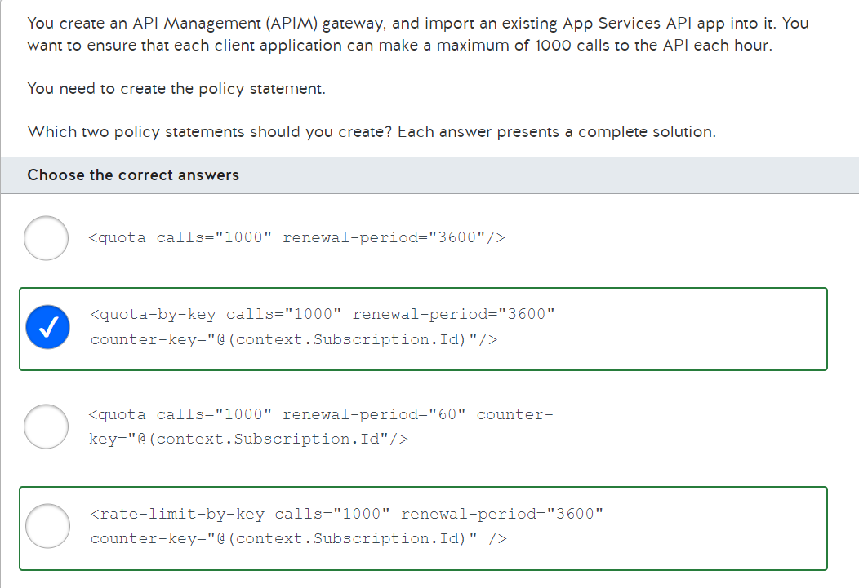

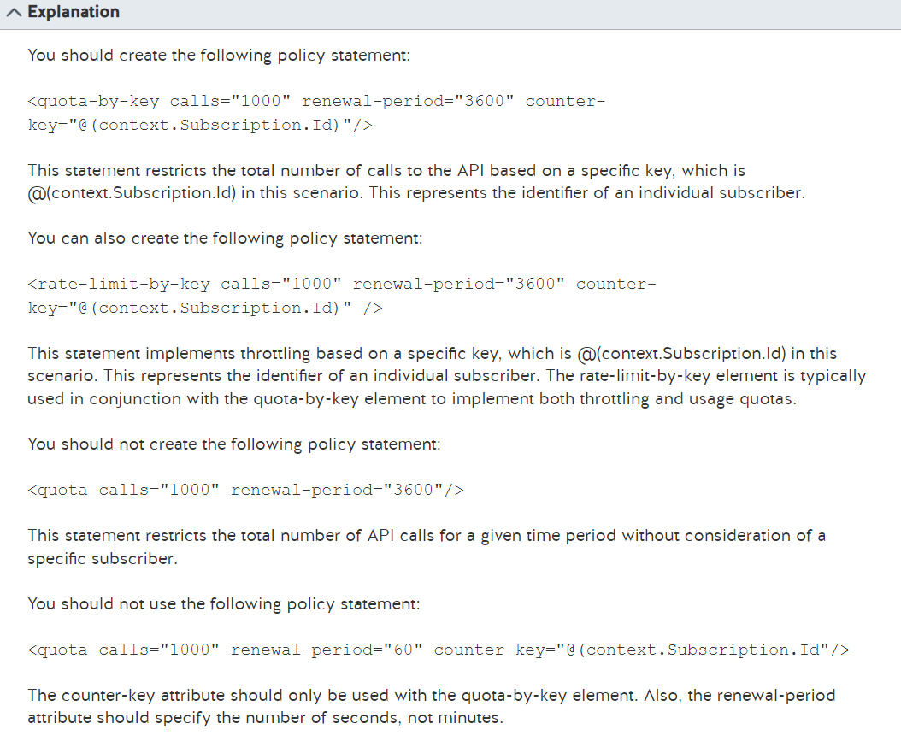

<https://docs.microsoft.com/bs-latn-ba/azure/api-management/api-management-access-restriction-policies>

<https://docs.microsoft.com/en-us/azure/api-management/api-management-sample-flexible-throttling>

<https://docs.microsoft.com/en-us/azure/api-management/transform-api>

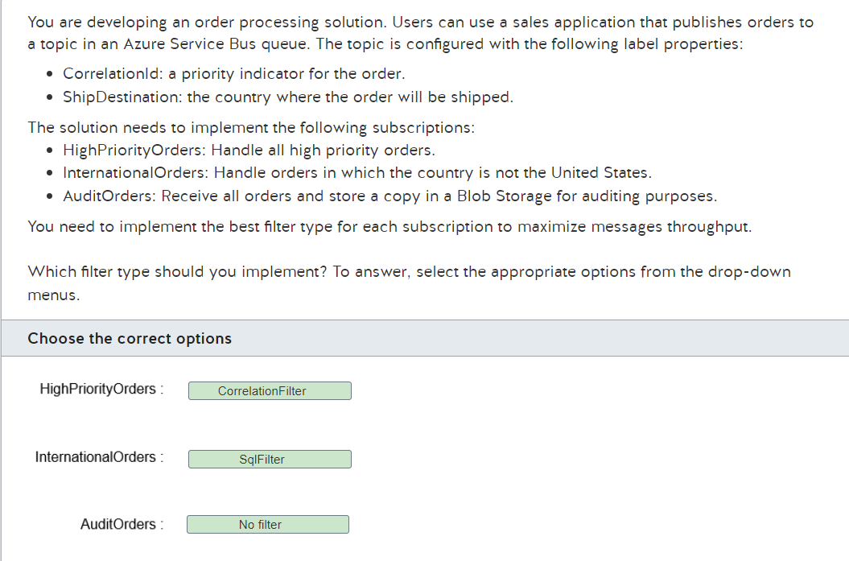

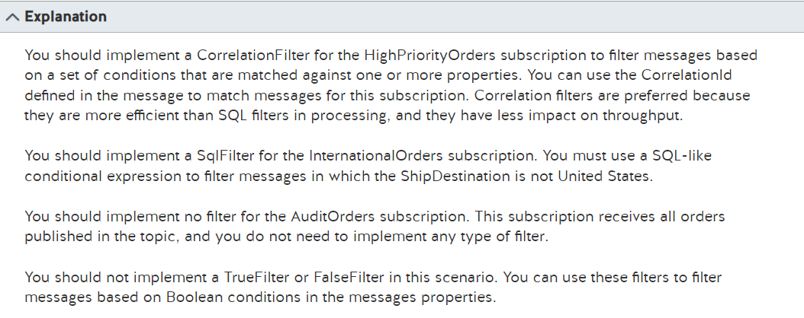

<https://docs.microsoft.com/en-us/azure/service-bus-messaging/topic-filters>

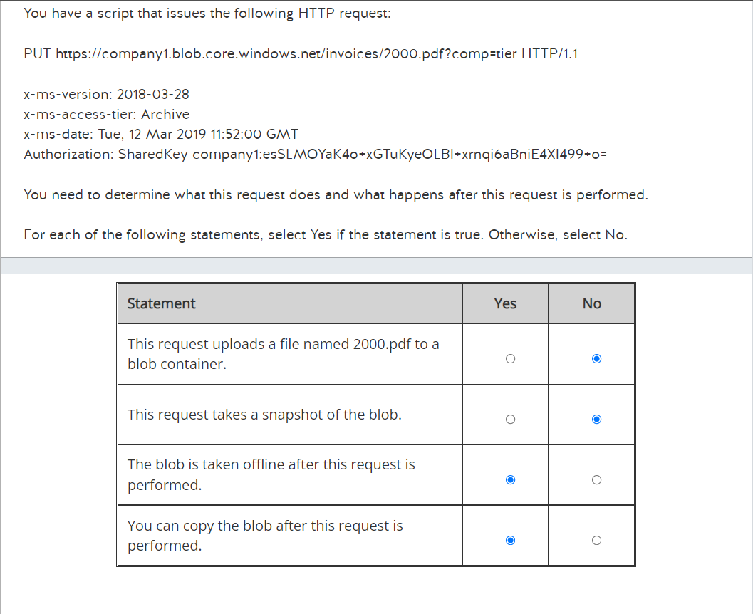

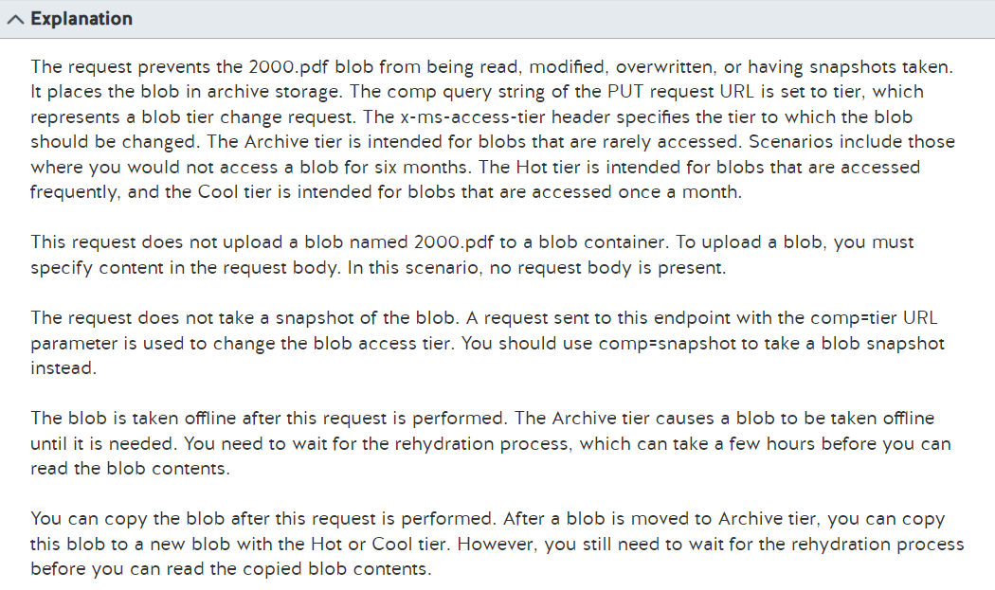

<https://docs.microsoft.com/en-us/rest/api/storageservices/snapshot-blob>

<https://docs.microsoft.com/en-us/rest/api/storageservices/set-blob-tier>

<https://docs.microsoft.com/en-us/azure/storage/blobs/access-tiers-overview>

<https://docs.microsoft.com/en-us/azure/storage/blobs/archive-rehydrate-overview>

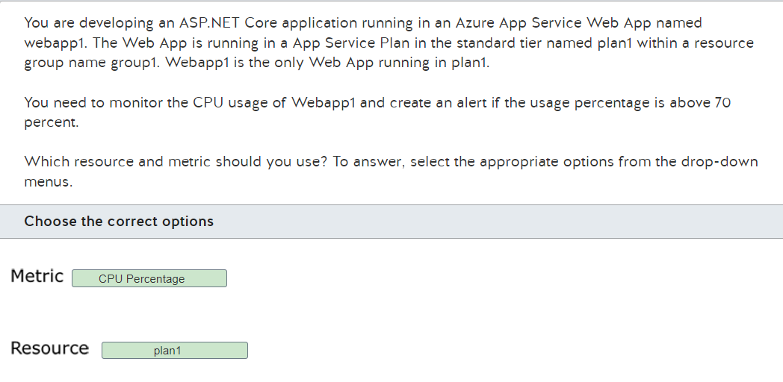

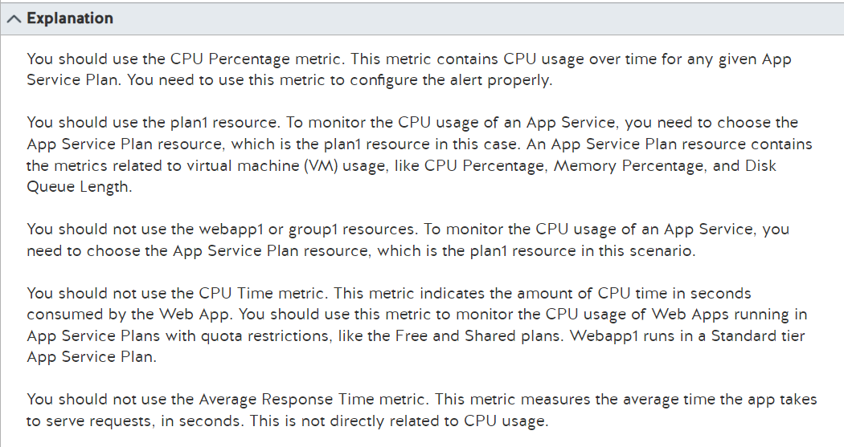

<https://docs.microsoft.com/en-us/azure/app-service/web-sites-monitor>

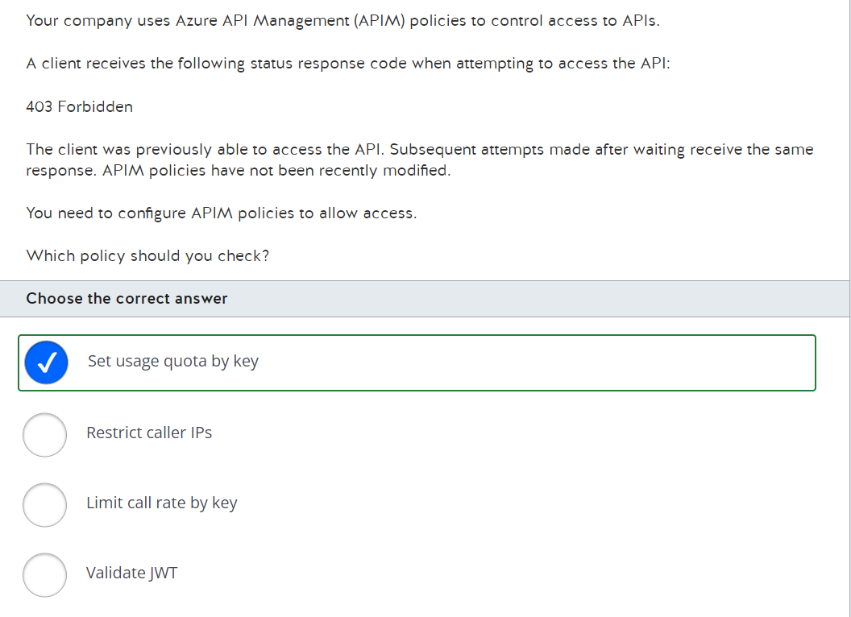

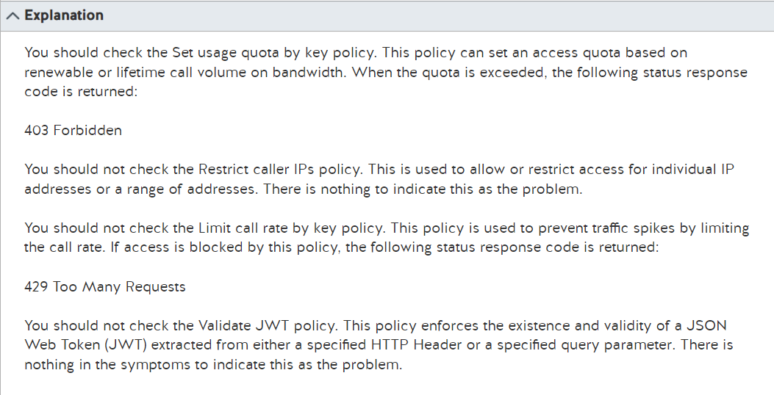

<https://docs.microsoft.com/en-us/azure/api-management/api-management-policies>

<https://docs.microsoft.com/en-us/azure/api-management/api-management-access-restriction-policies>

https://docs.microsoft.com/en-us/azure/api-management/api-management-howto-policies